**AMERICAN INTERNATIONAL UNIVERSITY BANGLADESH (AIUB)**

**FACULTY OF SCIENCE & TECHNOLOGY**



Course Title

**INTRODUCTION TO DATABASE (CSC2108)**

**Semester: 04  
Section: [W ]**

**TITLE**

**E-Store Management System**

**Supervised By**

Nyme Ahmed

**Submitted By: Group no: 05**

|  |  |
| --- | --- |
| **Name** | **ID** |
| Anika Tabassum | 23-53089-3 |
| Zarin Anan | 23-55874-3 |
| Adiba Rahman Rudiya | 23-53459-3 |
|  |  |

**TABLE OF CONTENTS**

|  |  |  |
| --- | --- | --- |
| **TOPICS** | | **Page no.** |
| **Title Page** | | **1** |
| **Table of Content** | | **2** |
| **1.** | **Introduction** | **3** |
| **2.** | **Case Study** | **4** |
| **3.** | **ER Diagram** | **5** |
| **4.** | **Normalization** | **6-13** |
| **5.** | **Finalization** | **14** |
| **6.** | **Table Creation** | **15-23** |
| **7.** | **Data Insertion** | **24-32** |
| **8.** | **Query Test** | **33-41** |
| **9.** | **DB connection** | **42-47** |
| **10.** | **Conclusion** | **48** |
|  |  |  |

# **Introduction**

**Title: E-Store Management System**

The E-store Management system represents a product ordering and management system, illustrating how different entities like customers, admins, products, payments, deliveries, and orders interact. It ensures efficient order processing, payment tracking, and delivery management while organizing products into categories for easy access. The system benefits businesses by improving data organization, customer interaction, and overall efficiency, making transactions smoother and more structured.

# **Case Study / Scenario**

The Product Ordering and Management System is designed to streamline the process of purchasing, tracking, and delivering products. It involves key entities such as Customers, Admins, Products, Payments ,Categories, Delivery Details, and Data, each with specific attributes and relationships. Each customer has a unique ID which is a primary key, name, phone number, and address (city and country). Customers place orders, make payments, and receive deliveries. Admins, identified by a unique ID being primary key, manage the platform by overseeing customer records, product details, and category organization. Admins also have attributes like name, phone, email, and address. Products, with unique IDs being primary key, include names, prices, and availability and are organized into categories with unique IDs as primary key, names, and descriptions. Payments are tracked with unique IDs which is also a primary key, dates, and amounts, while delivery records include unique IDs being primary key, addresses, phone numbers, and delivery dates. Reservation data logs quantities and reservation dates. Admins ensure the system’s smooth operation by linking customers, products, and categories effectively.

# **ER Diagram**

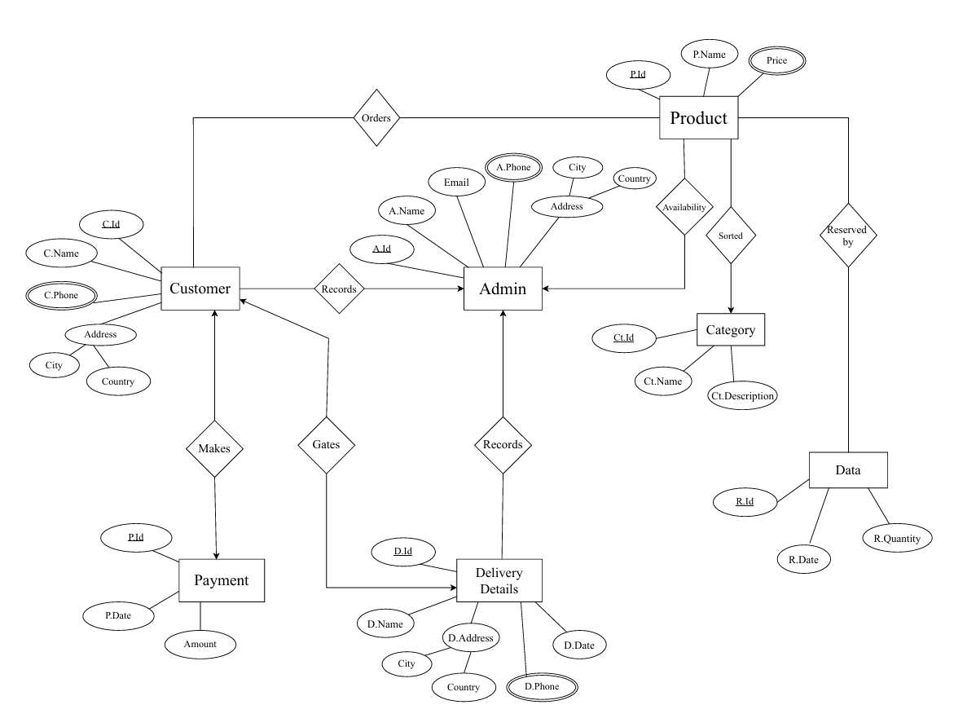

# **Normalization**

**Diagram: Customer to Delivery**

Delivery

Details

Gates

Customer

C.Phone

C.Name

Address

C-Id

C.Country

C.City

D-Id

D.Name

D.Address

D.City

D.Country

D.Phone

D.Date

**Relation: One to One.**

**UNF:**  C-Id , C.Name, C.Phone, C.City, C.Country, D-Id , D.Name, D.Phone, D.City, D.Country, D.Date.

**1NF:** Multivalued Attribute: C.Phone, D.Phone.

C-Id , C.Name, C.City, C.Country, D-Id , D.Name, D.City, D.Country, D.Date.

**2NF:** 1. C-Id , C.Phone.

2. D-Id , D.Phone.

3. C-Id , C.Name, C.City, C.Country,

4. D-Id , D.Name, D.City, D.Country, D.Date.

**3NF:** 1. C-Id , C.Phone.

2. C-Id ,C.City, C.Country.

3. C-Id , C.Name.

4. D-Id , D.Phone.

5. D-Id ,D.City, D.Country.

6. D-Id , D.Name, D.Date.

**Diagram: Admin to Delivery Details:**

Admin

Delivery

Details

Records

A-Id

A.Phone

A.Name

Email

Address

A.Country

A.City

D-Id

D.Name

D.Address

D.City

D.Country

D.Phone

D.Date

**Relation: One to Many.**

**UNF:** A-Id, A.Name, Email, A.Phone, A.City, A.Country, D-Id, D.Name, D.City, D.Country, D.Phone, D.Date.

**1NF:** Multivalued Attribute: A.Phone, D.Phone.

A-Id, A.Name, Email, A.City, A.Country, D-Id, D.Name, D.City, D.Country, D.Date.

**2NF:** 1. A-Id, A.Phone.

2. D-Id, D.Phone.

3. A-Id, A.Name, Email, A.City, A.Country.

4. D-Id, D.Name, D.City, D.Country, D.Date, A-Id.

**3NF:** 1. A-Id, A.Phone.

2. D-Id, D.Phone.

3. A-Id, A.City, A.Country.

4. A-Id, A.Name, Email.

5. D-Id, D.City, D.Country.

6. D-Id, D.Name, D.Date, A-Id.

**Foreign key:** A-Id.

**Diagram:** **Admin to Product:**

Admin

Product

Availability

A-Id

A.Phone

A.Name

Email

Address

A.Country

A.City

Pr-Id

Pr.Name

Price

**Relation: One to Many.**

**UNF:** A-Id, A.Name, Email, A.Phone, A.City, A.Country, Pr-Id, Pr.Name, Price.

**1NF:** Multivalued Attribute:A.Phone, Price.

A-Id, A.Name, Email, A.City, A.Country, Pr-Id, Pr.Name.

**2NF:** 1. A-Id , A.Phone.

2. Pr-Id, Price.

3. A-Id, A.Name, Email, A.City, A.Country.

4.Pr-Id, Pr.Name, A-Id.

**3NF:** 1. A-Id , A.Phone.

2. A-Id, A.City, A.Country.

3. A-Id, A.Name, Email.

4. Pr-Id, Price.

5. Pr-Id, Pr.Name, A-Id.

**Foreign key:** A-Id.

**Diagram: Customer to Admin:**

Admin

Records

Customer

C.Phone

C.Name

Address

C-Id

C.Country

C.City

A-Id

A.Phone

A.Name

Email

Address

A.Country

A.City

**Relation: Many to One.**

**UNF:** C-Id, C.Name, C.Phone, C.City, C.Country, A-Id, A.Name, Email, A.Phone, A.City, A.Country.

**1NF:** Multivalued Attribute: C.Phone, A.Phone.

C-Id, C.Name, C.City, C.Country, A-Id, A.Name, Email, A.City, A.Country.

**2NF:** 1. C-Id , C.Phone.

2. A-Id , A.Phone.

3. C-Id , C.Name, C.City, C.Country, A-Id.

4. A-Id, A.Name, Email, A.City, A.Country.

**3NF:** 1. C-Id , C.Phone.

2. A-Id , A.Phone.

3. C-Id , C.City, C.Country.

4. C-Id , C.Name, A-Id.

5. A-Id, A.City, A.Country.

6. A-Id, A.Name, Email.

**Foreign key:** A-Id.

**Diagram: Product to Category:**

Product

Sorted

Pr-Id

Pr.Name

Price

Category

Ct-Id

Ct.Name

Ct.Description

**Relation: Many to One.**

**UNF:** Pr-Id, Pr.Name, Price, Ct-Id, Ct.Name, Ct.Description.

**1NF:** Multivalued Attribute:Price.

Pr-Id, Pr.Name, Ct-Id, Ct.Name, Ct.Description.

**2NF:** 1. Pr-Id, Price.

2. Pr-Id, Pr.Name, Ct-Id.

3. Ct-Id, Ct.Name, Ct.Description.

**3NF:** 1. Pr-Id, Price.

2. Pr-Id, Pr.Name, Ct-Id.

3. Ct-Id, Ct.Name, Ct.Description.

**Foreign Key:** Ct-Id.

**Diagram: Customer to Payment:**

Payment

Pays

Customer

C.Phone

C.Name

Address

C-Id

C.Country

C.City

P-Id

P.Date

Amount

**Relation: One to One.**

**UNF:** C-Id, C.Name, C.Phone, C.City, C.Country, P-Id, P.Date, Amount.

**1NF:** Multivalued Attribute: C.Phone.

C-Id, C.Name, C.City, C.Country, P-Id, P.Date, Amount.

**2NF:** 1. C-Id , C.Phone.

2. P-Id , P.Date, Amount.

3. C-Id , C.Name, C.City, C.Country.

**3NF:** 1. C-Id , C.Phone.

2. C-Id , C.City, C.Country.

3. C-Id , C.Name.

4. P-Id , P.Date, Amount.

**Diagram: Customer to Product:**

Product

Orders

Customer

C.Phone

C.Name

Address

C-Id

C.Country

C.City

Pr-Id

Pr.Name

Price

**Relation: Many to Many.**

**UNF:** C-Id, C.Name, C.Phone, C.City, C.Country, Pr-Id, Pr.Name, Price.

**1NF:** Multivalued Attribute: C.Phone, Price.

C-Id, C.Name, C.City, C.Country, Pr-Id, Pr.Name.

**2NF:** 1. C-Id , C.Phone.

2. Pr-Id, Price.

3. C-Id , C.Name, C.City, C.Country, Pr-Id.

4.Pr-Id, Pr.Name.

**3NF:** 1. C-Id , C.Phone.

2. C-Id , C.City, C.Country.

3. C-Id , C.Name, Pr-Id.

4. Pr-Id, Price.

5.Pr-Id, Pr.Name.

**Foreign key:** Pr-Id.

**Diagram: Product to Data:**

Product

Data

Reserved

by

Pr-Id

Pr.Name

Price

R-Id

R.Date

R.Quantity

**Relation: Many to Many.**

**UNF:** Pr-Id, Pr.Name, Price, R-Id, R.Date, R.Quantity.

**1NF:** Multivalued Attribute:Price.

Pr-Id, Pr.Name, R-Id, R.Date, R.Quantity.

**2NF:** 1. Pr-Id, Price.

2. Pr-Id, Pr.Name, R-Id.

3. R-Id, R.Date, R.Quantity.

**3NF:** 1. Pr-Id, Price.

2. Pr-Id, Pr.Name, R-Id.

3. R-Id, R.Date, R.Quantity.

**Foreign Key:** R-Id.

# **Finalization**

**Finalization:**

1. A-Id, A.Phone. (Admin)
2. A-Id, A.City, A.Country. (Admin1)
3. A-Id, A.Name, Email.(Admin2)
4. C-Id , C.Phone. (Customer1)
5. C-Id , C.City, C.Country. (Customer2)
6. C-Id , C.Name, A-Id. (Customer3)
7. 7. D-Id, D.Phone. (Delivery_Details1)
8. D-Id, D.City, D.Country.(Delivery_Details2)
9. D-Id, D.Name, D.Date, A-Id. .(Delivery_Details3)
10. C-Id , C.Name, Pr-Id. (Customer4)
11. Pr-Id, Pr.Name, A-Id. (Product1)
12. Pr-Id, Price. (Product2)
13. Pr-Id, Pr.Name, Ct-Id. (Product3)
14. Pr-Id, Pr.Name, R-Id. (Product4)
15. 16.Ct-Id, Ct.Name, Ct.Description. (Category)
16. 17. P-Id , P.Date, Amount. (Payment)
17. 18.R-Id, R.Date, R.Quantity. (Data)

# **Table Creation (DDL Operations)**

|  |  |  |
| --- | --- | --- |
| StudentID1: 23-53089-3 Name: Anika Tabassum | StudentID3: 23-53459-3 Name: Adiba Rahman Rudiya | |
| StudentID2: 23-55874-3 Name: Zarin Anan | StudentID4: N/A Name: N/A | |
| **CO4**: Creating DML, DDL using Oracle and connection with ODBC/JDBC for existing JAVA application | | |
| **PO-e-2:** Use modern engineering and IT tools for prediction and modeling of complex computer science and engineering problem | | Marks |

**1)Admin**

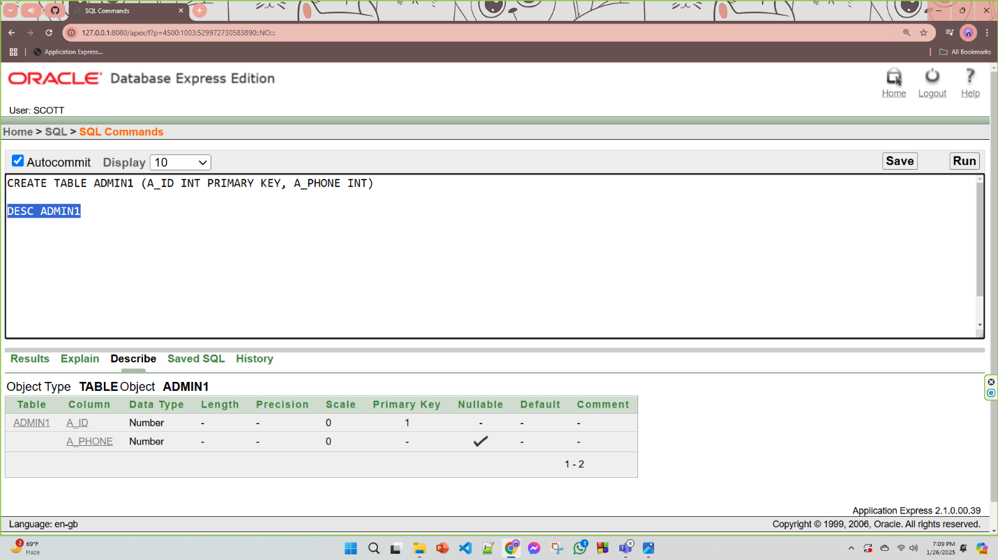

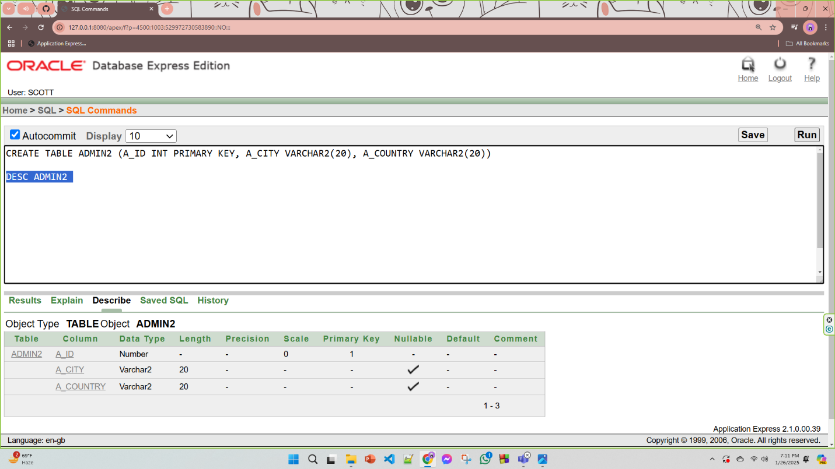

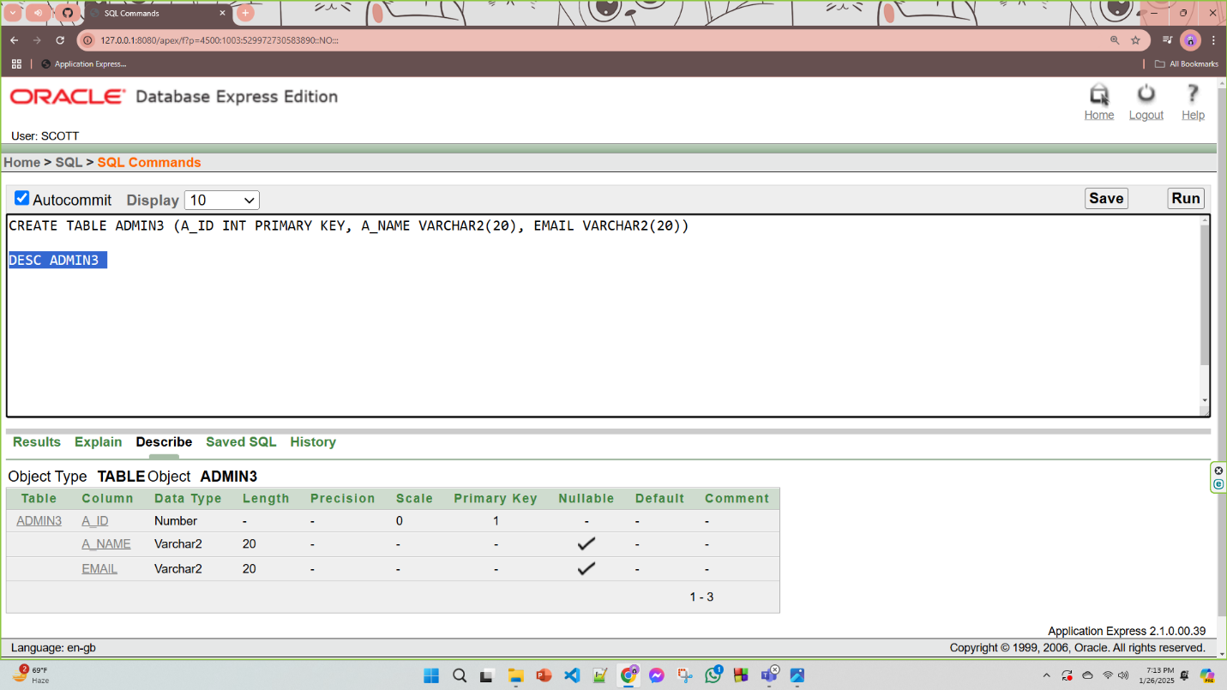

**2)Customer**

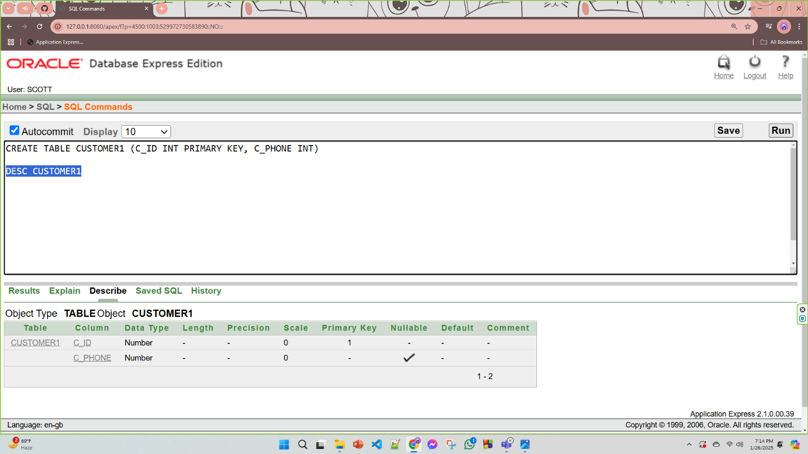

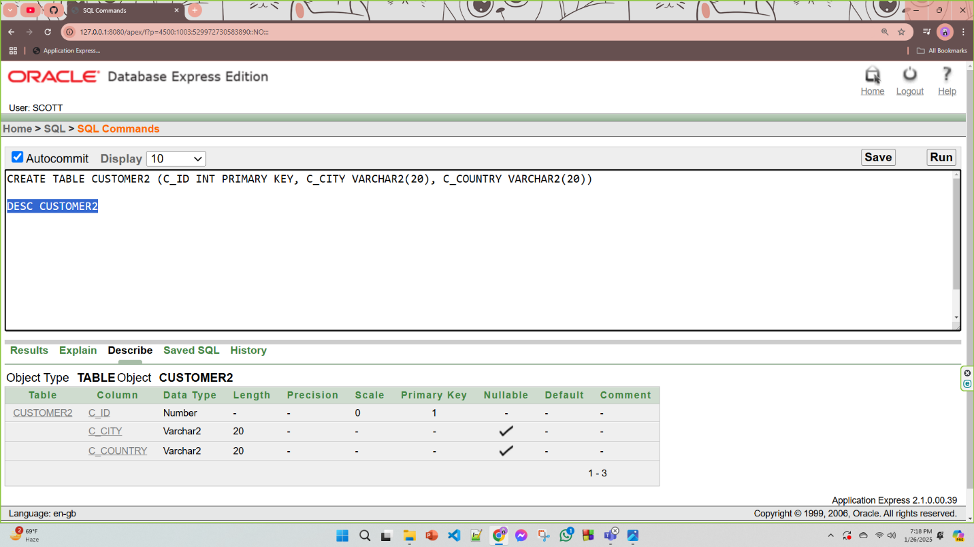

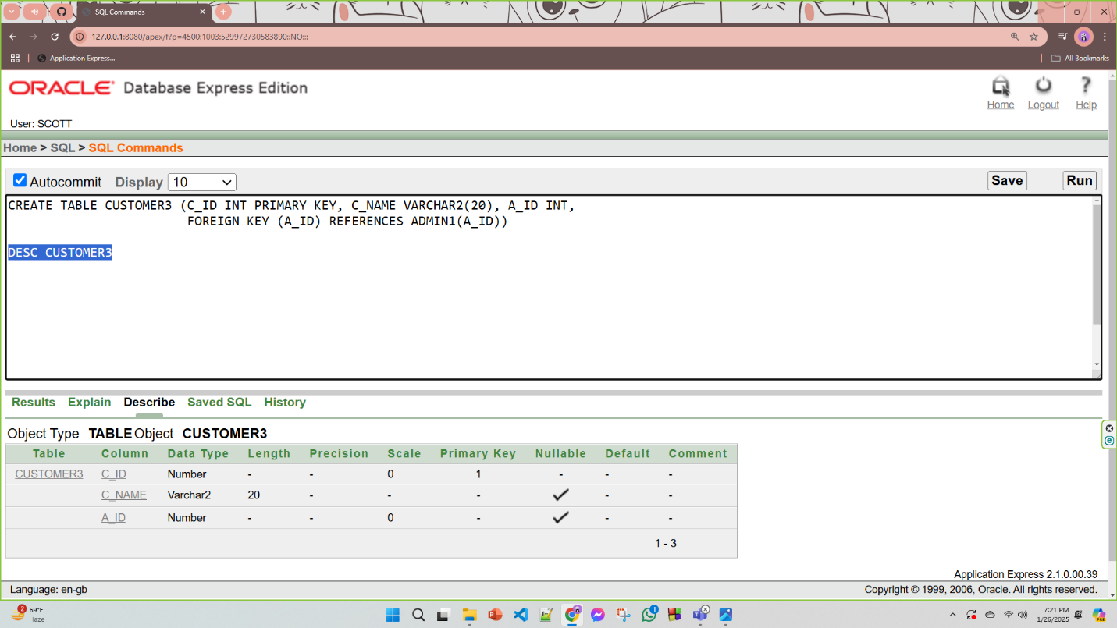

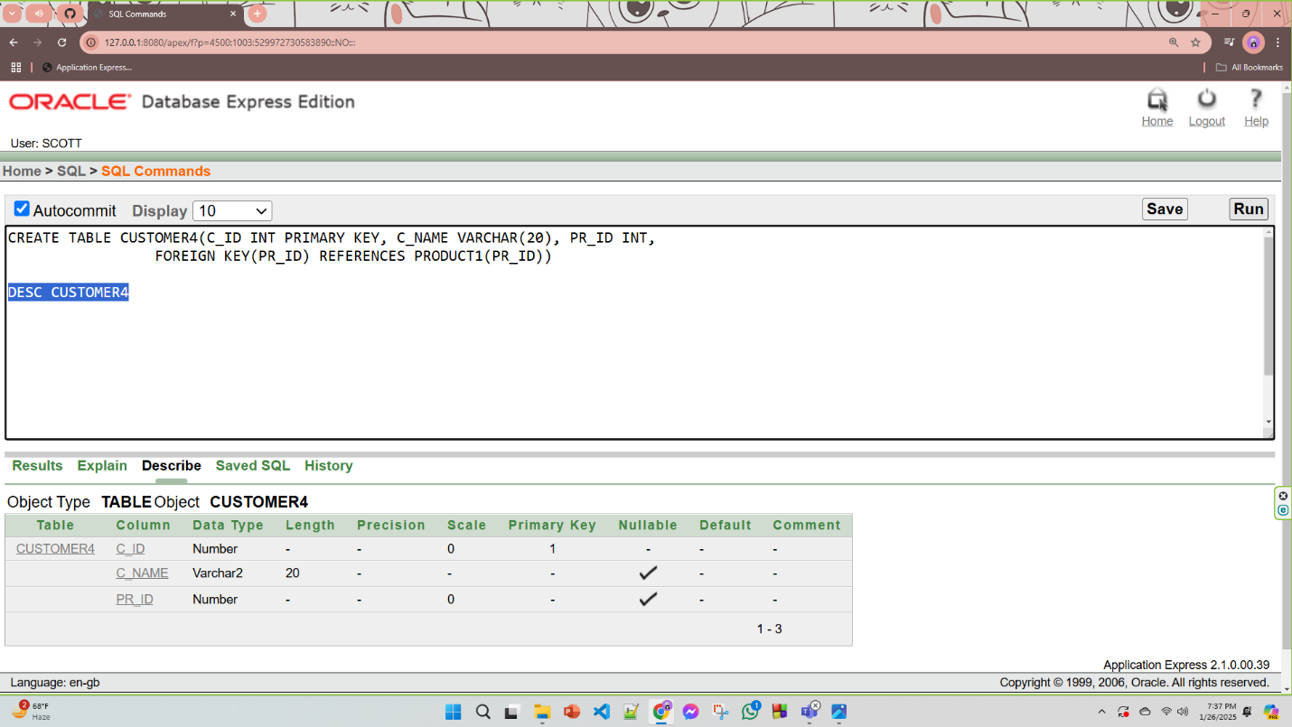

**3)Delivery Details**

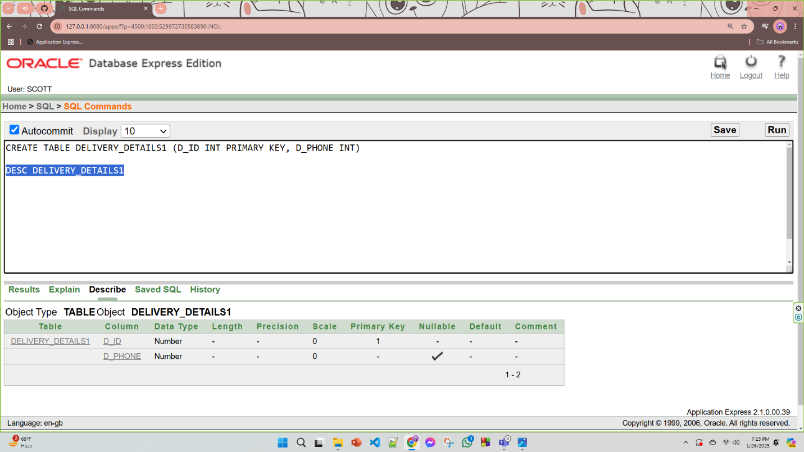

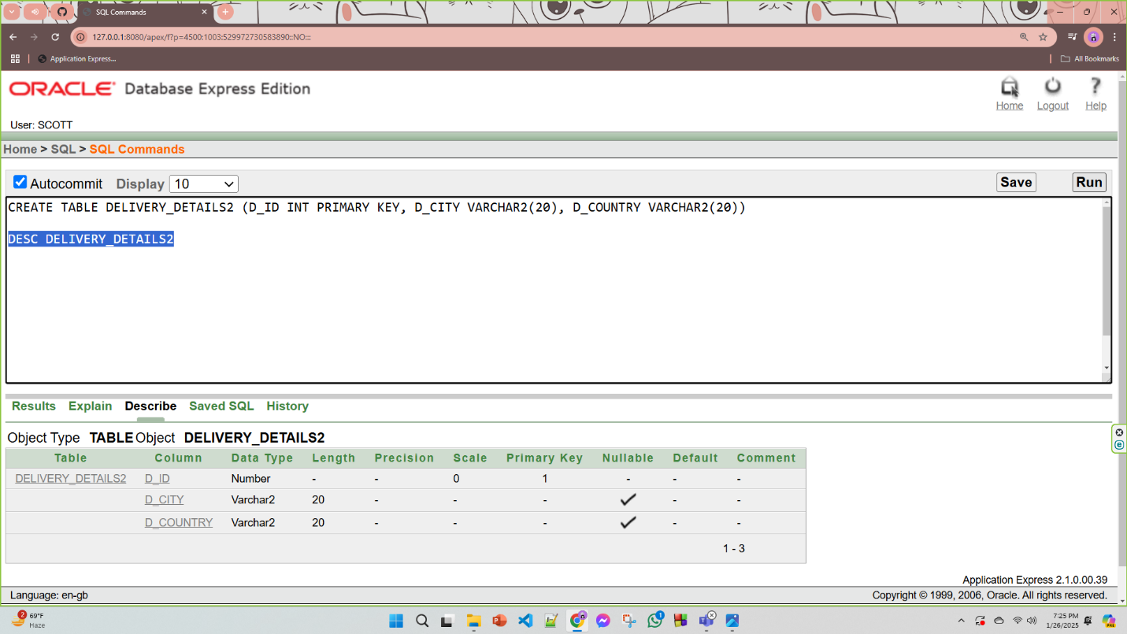

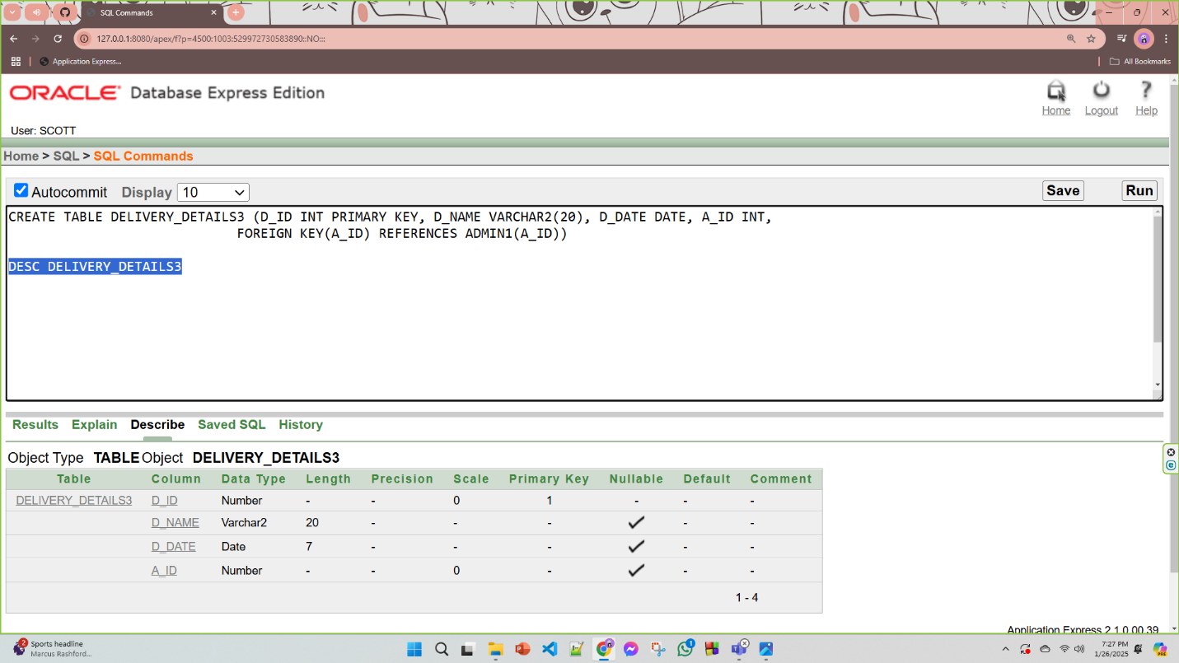

**4)Product**

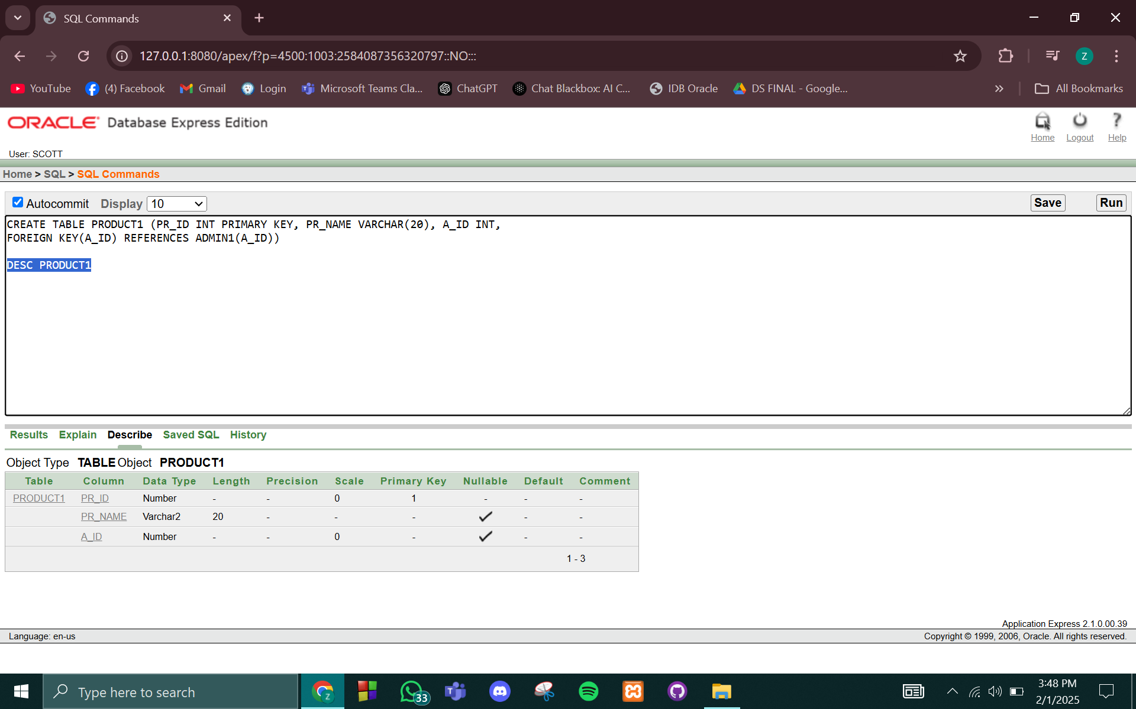

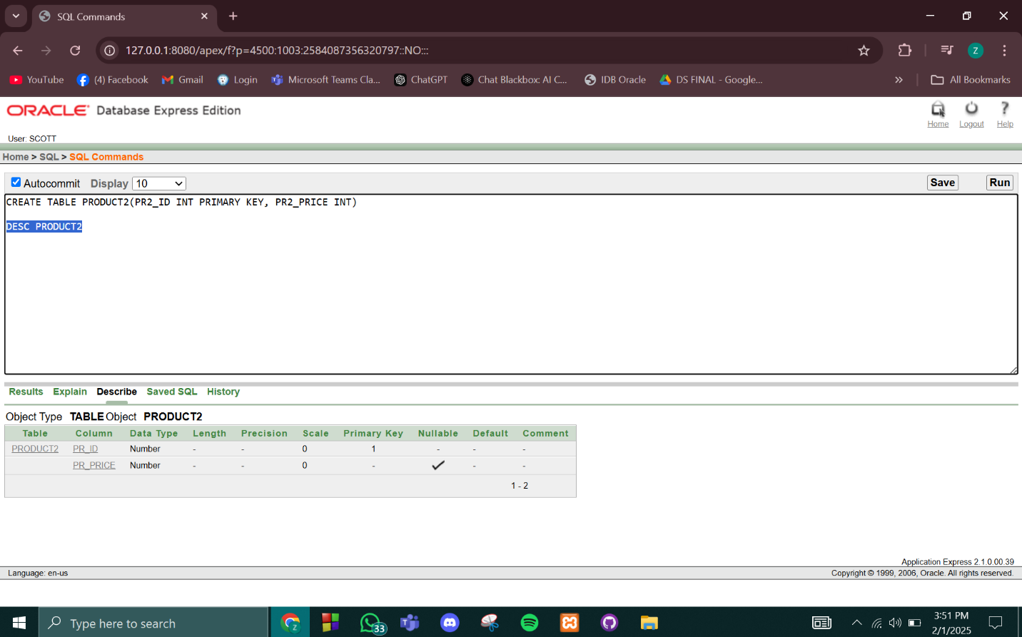

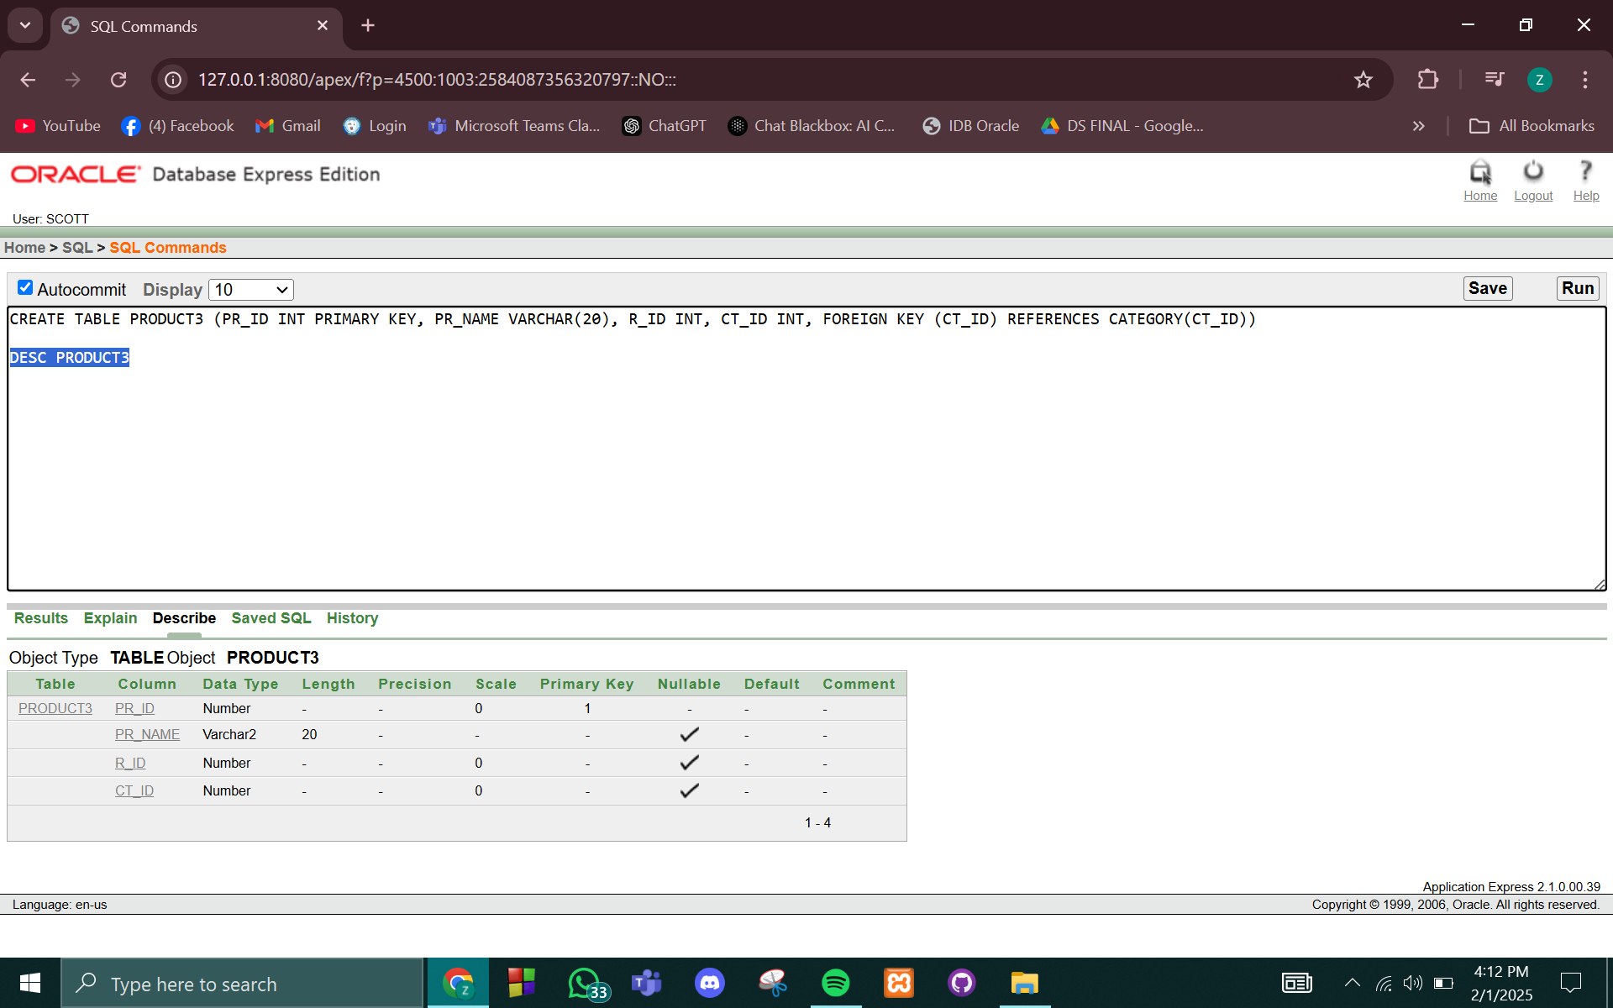

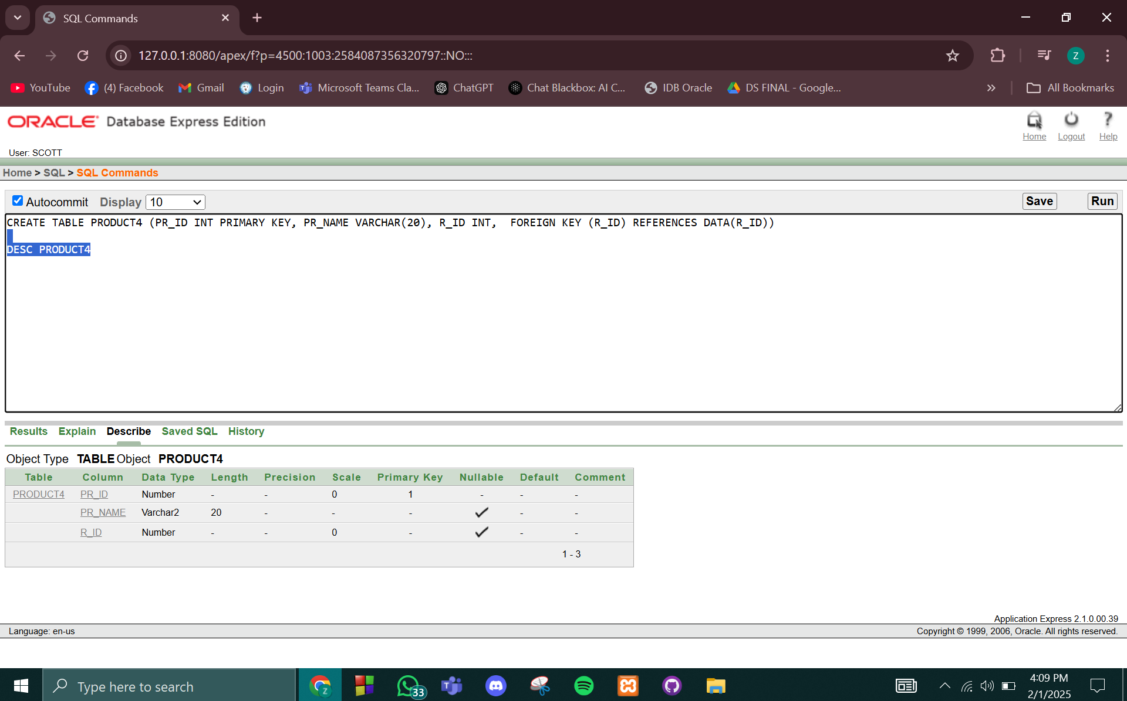

**5)Category**

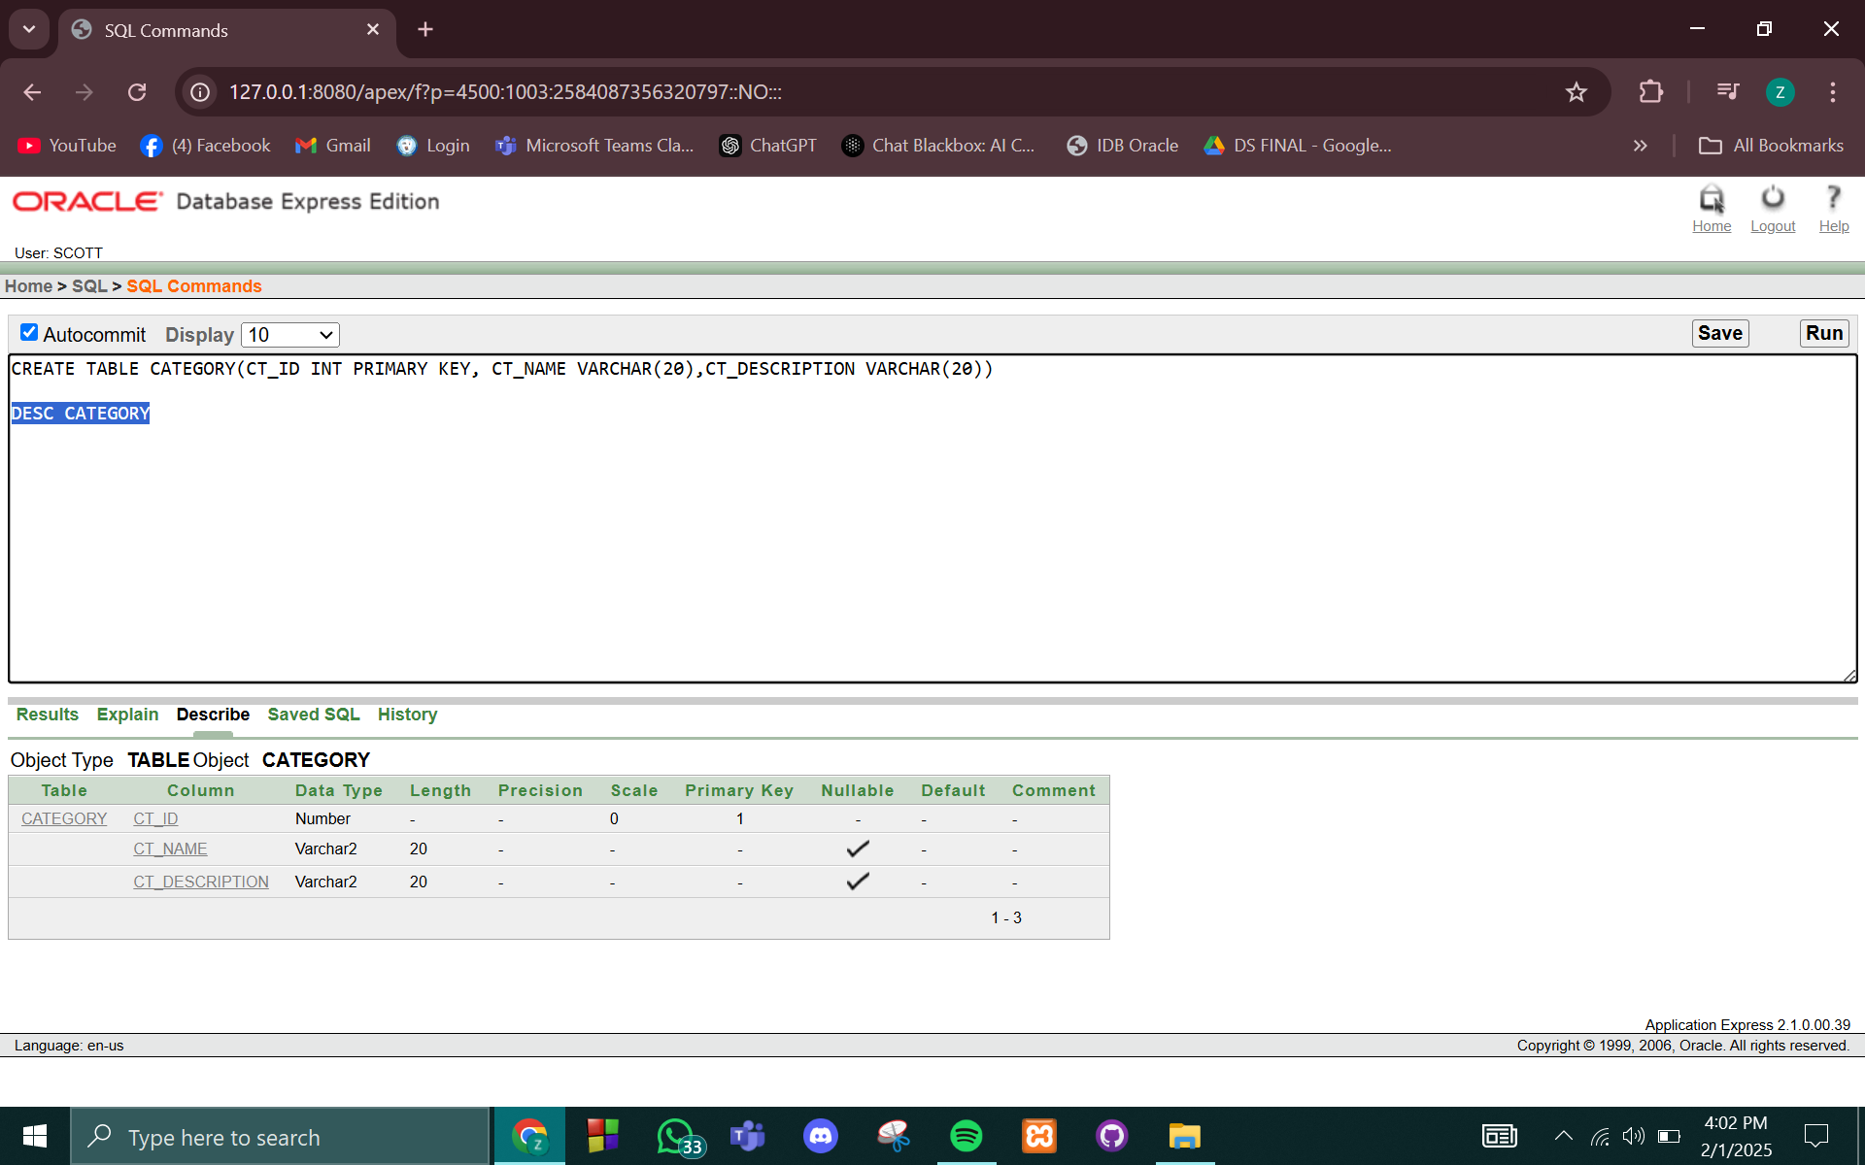

**6)Payment**

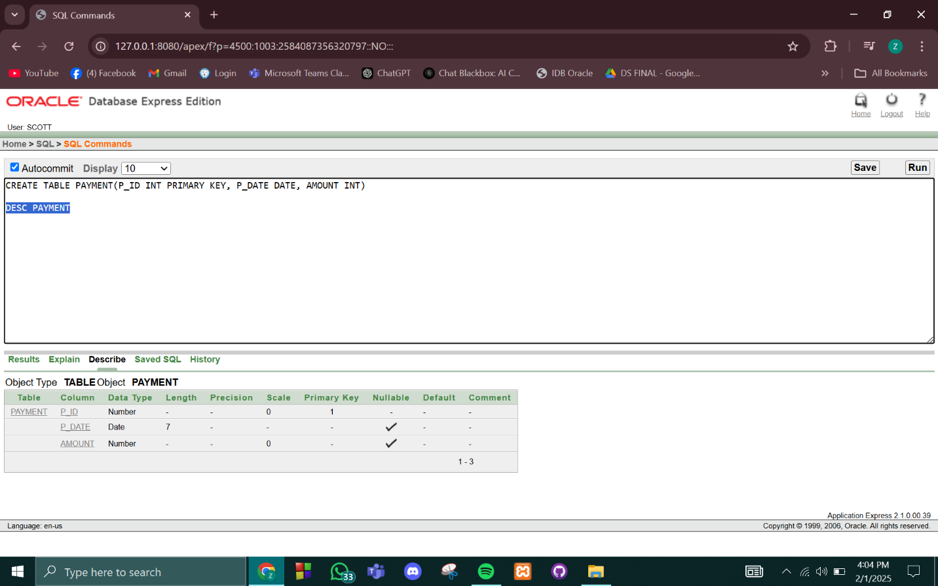

**7)Data**

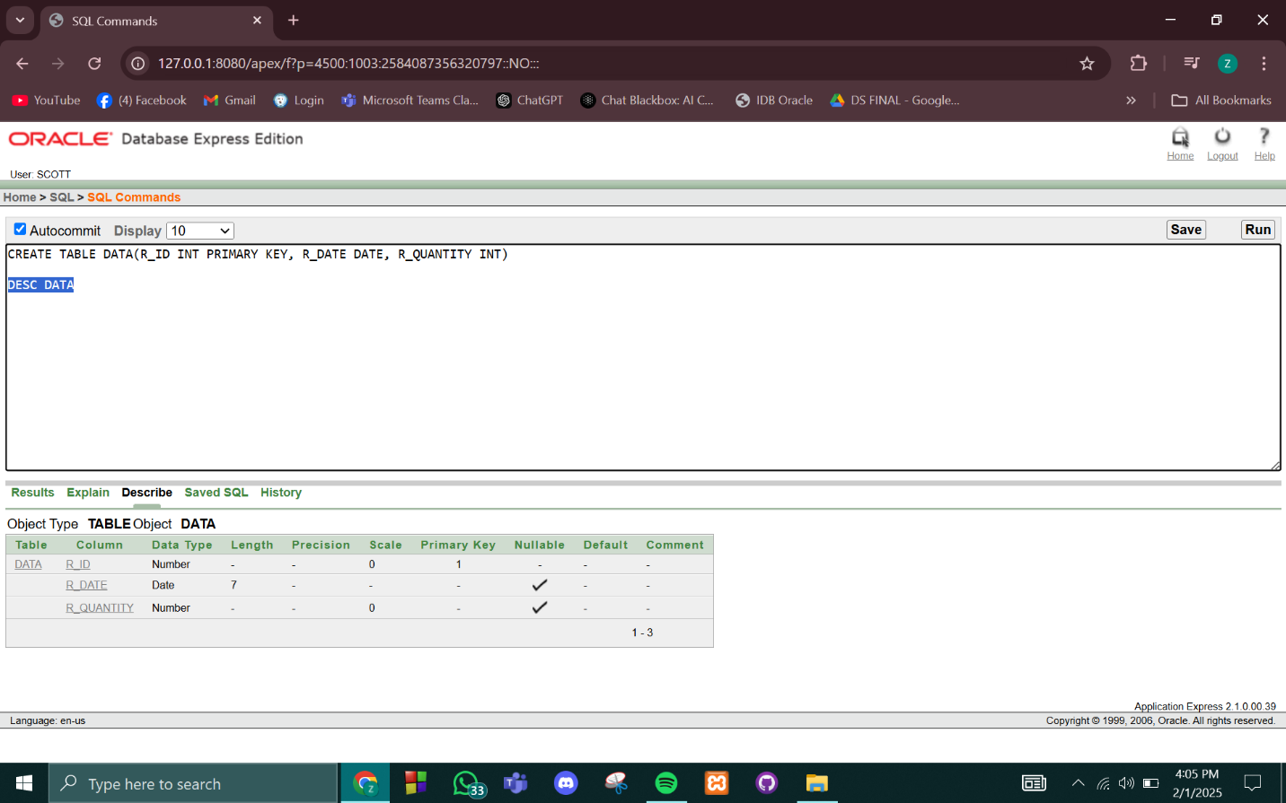

# **Inserted Values in the tables**

**1)Admin**

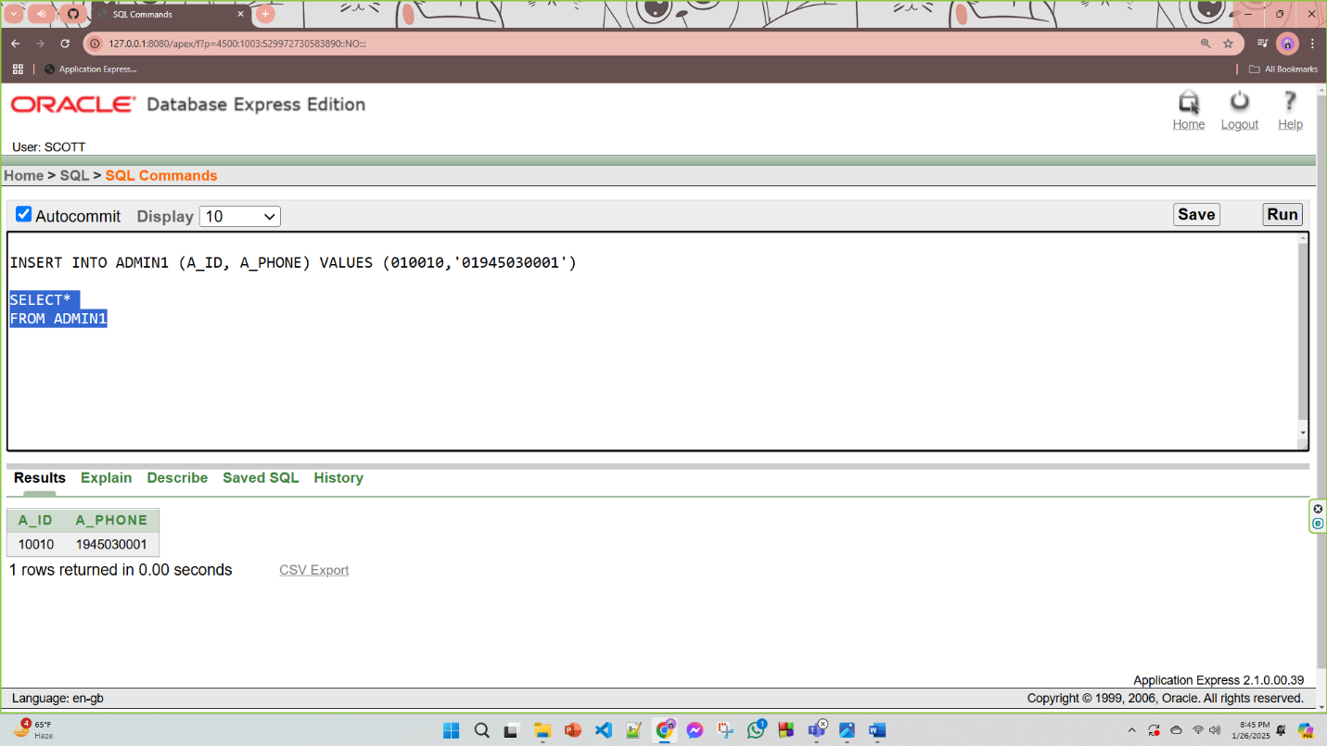

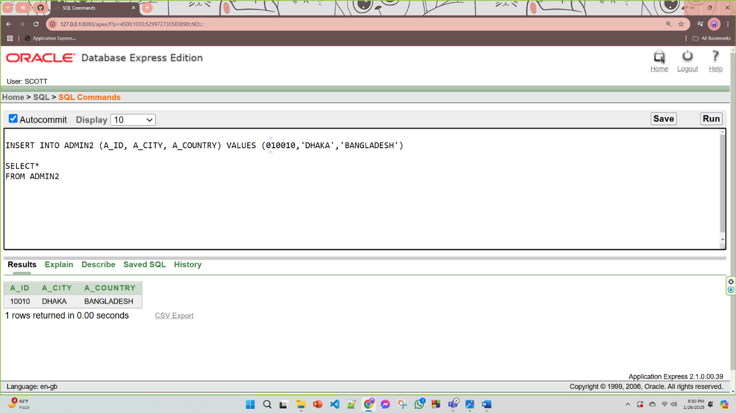

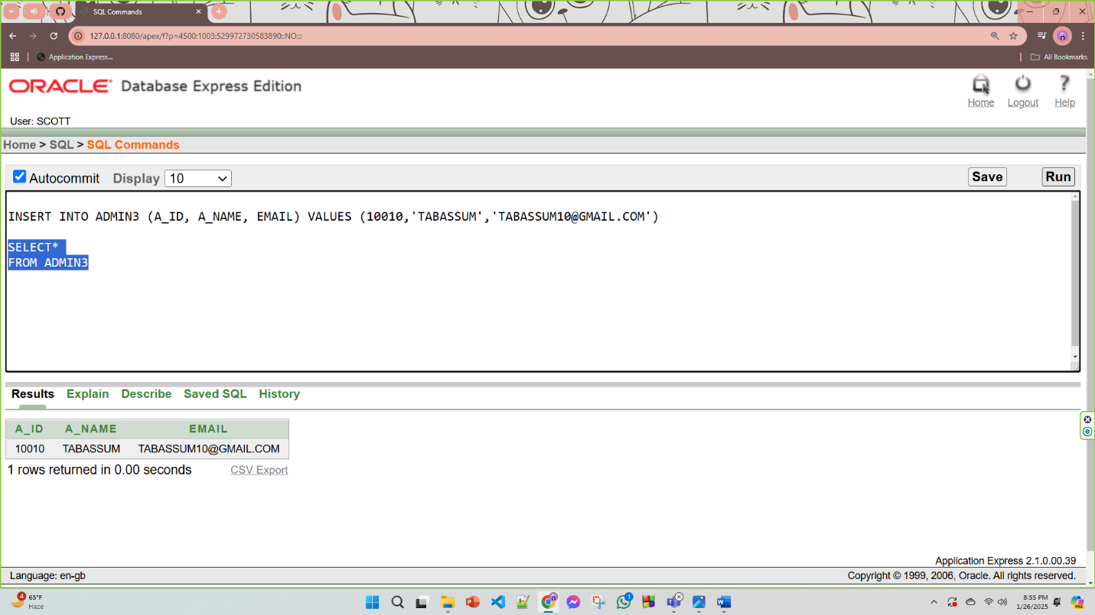

**2)Customer**

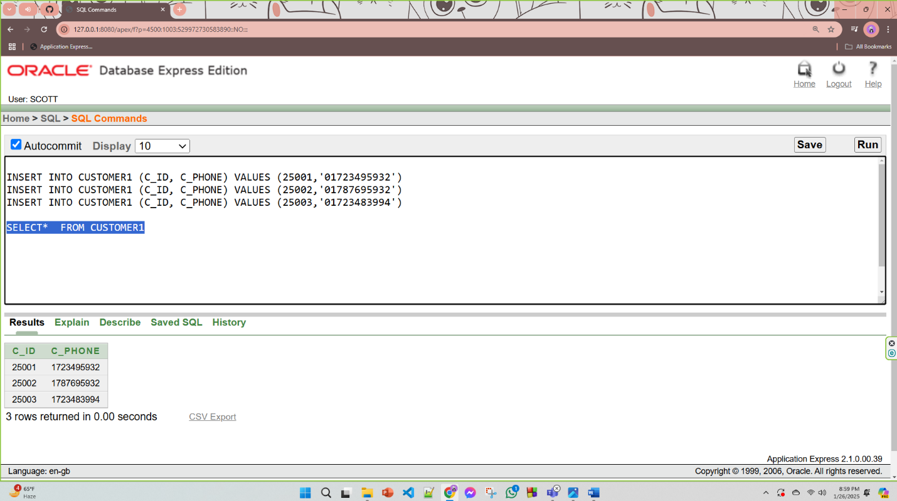

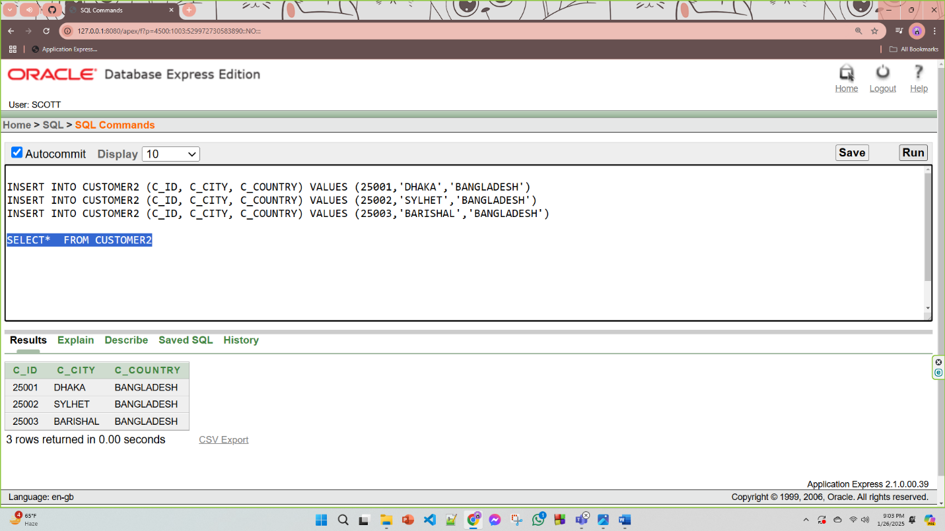

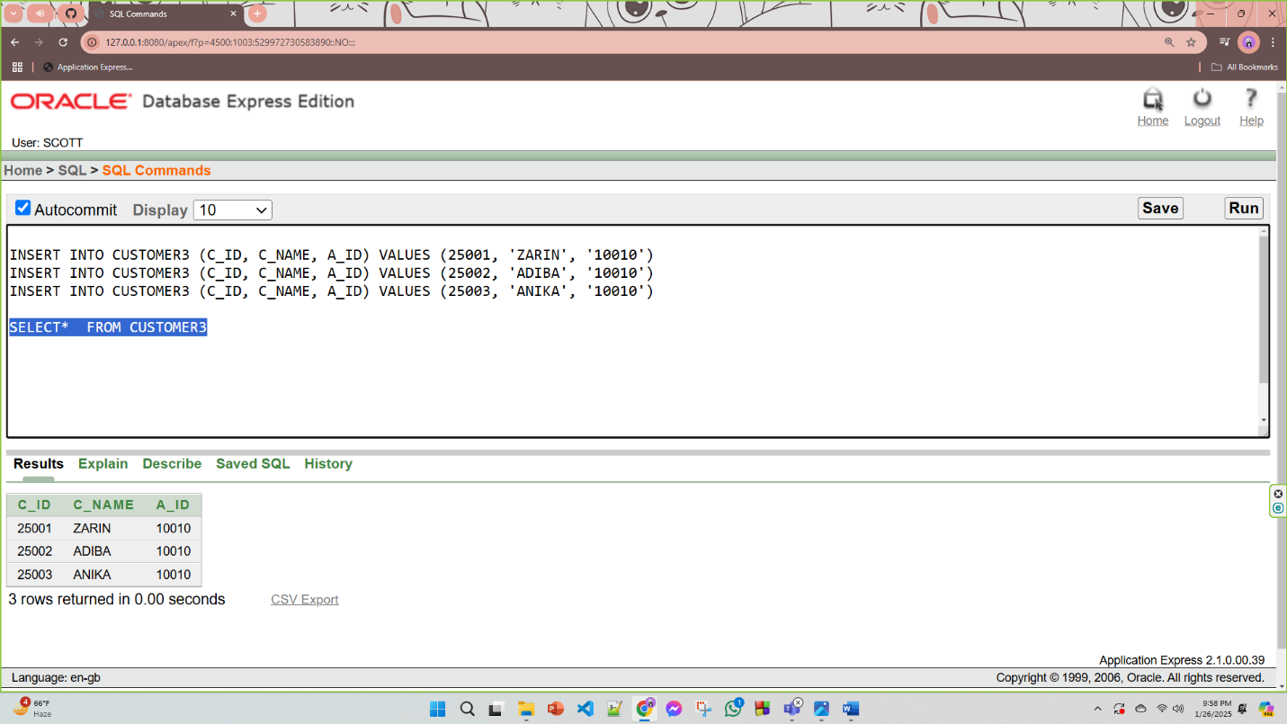

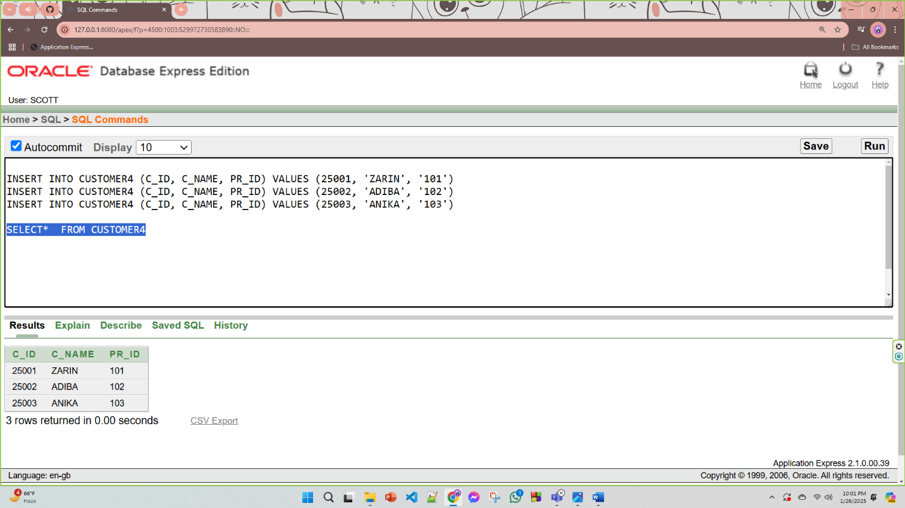

**3)Delivery Details**

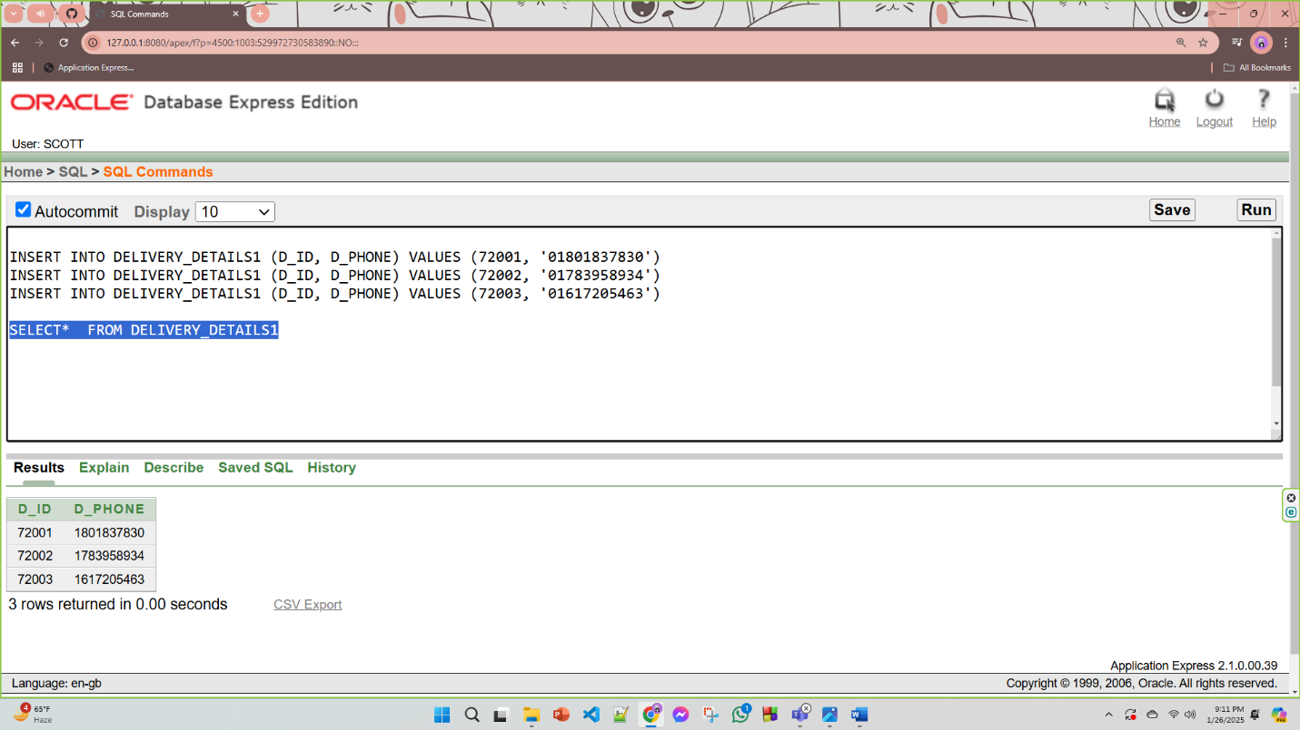

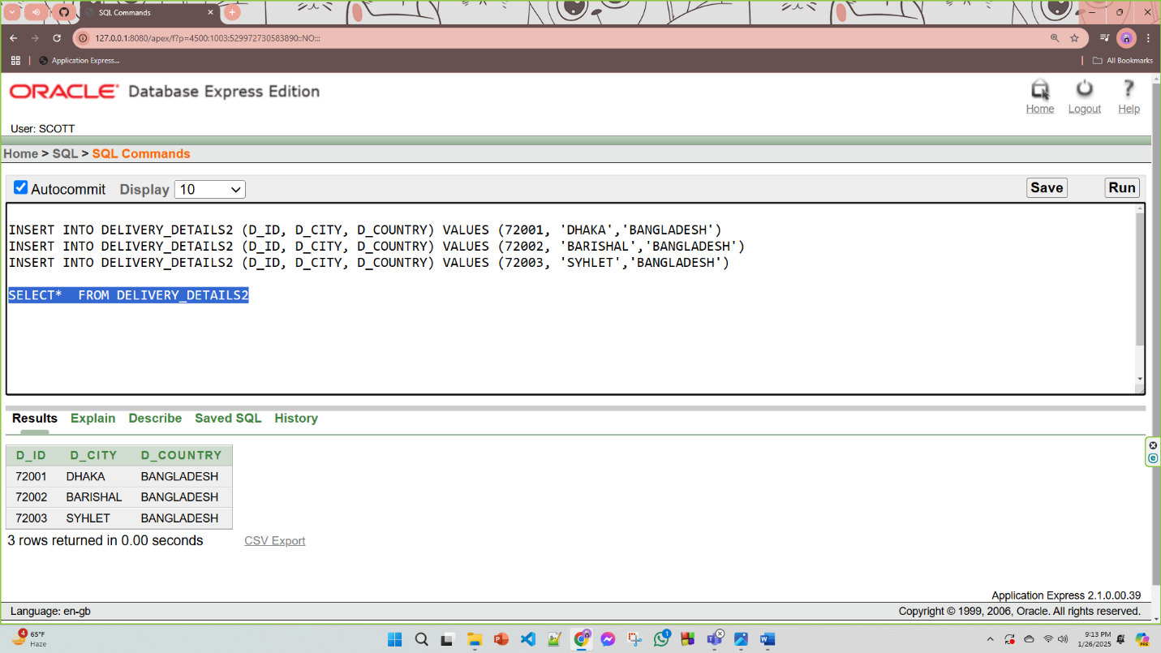

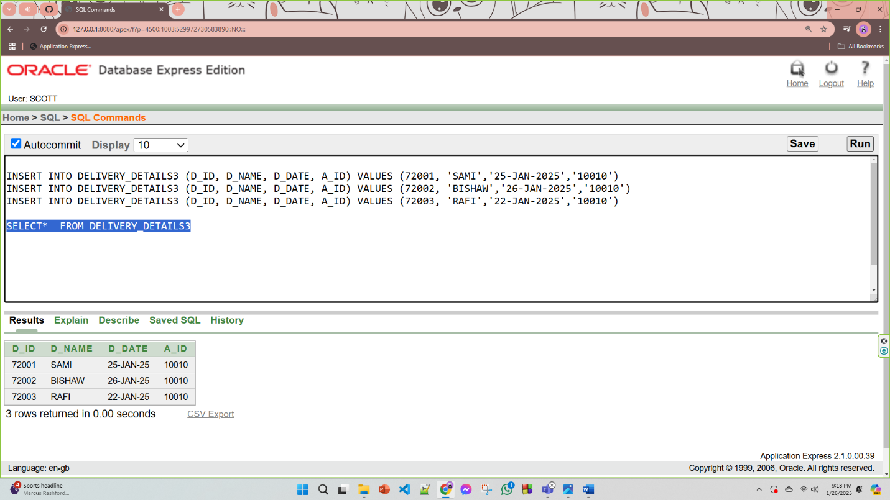

**4)Product**

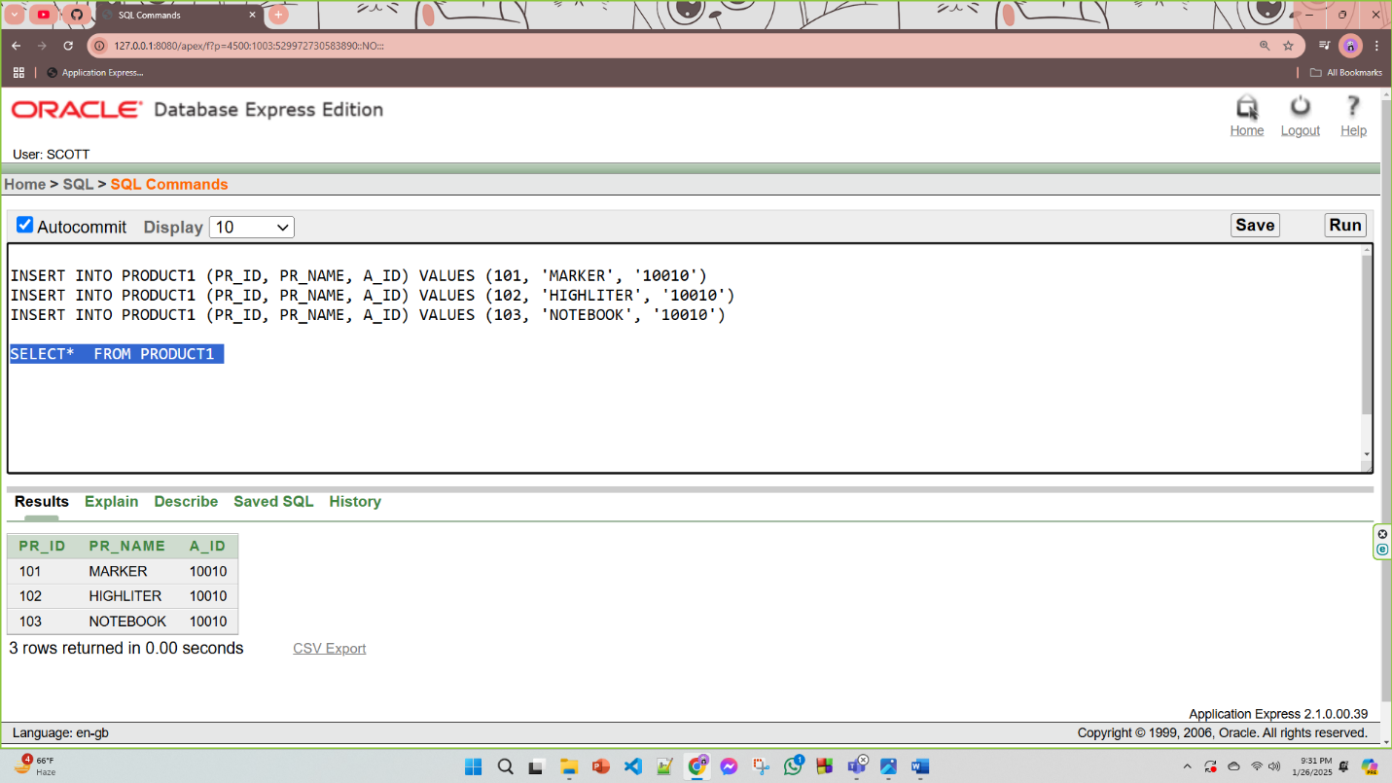

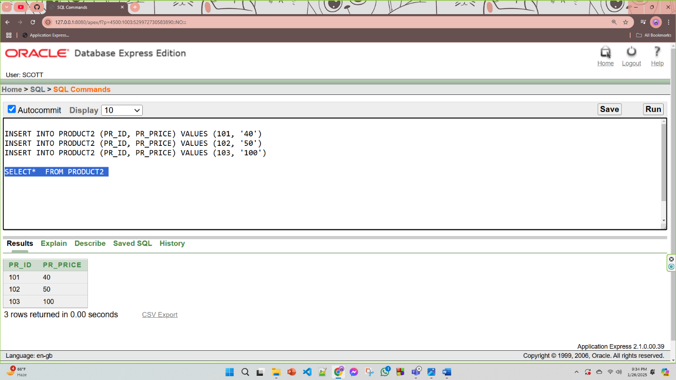

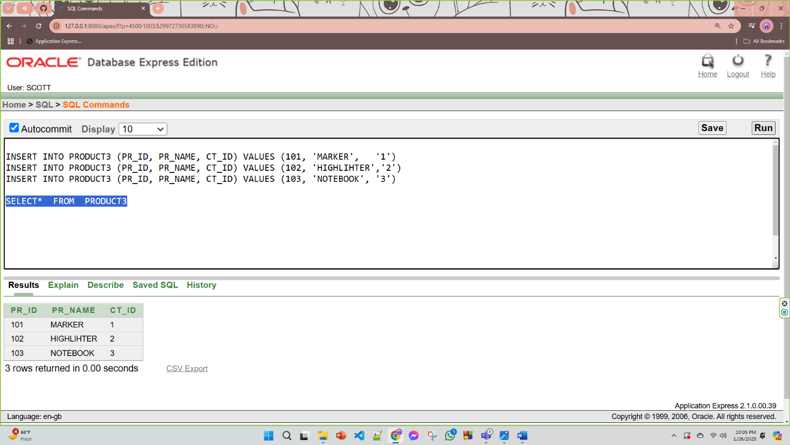

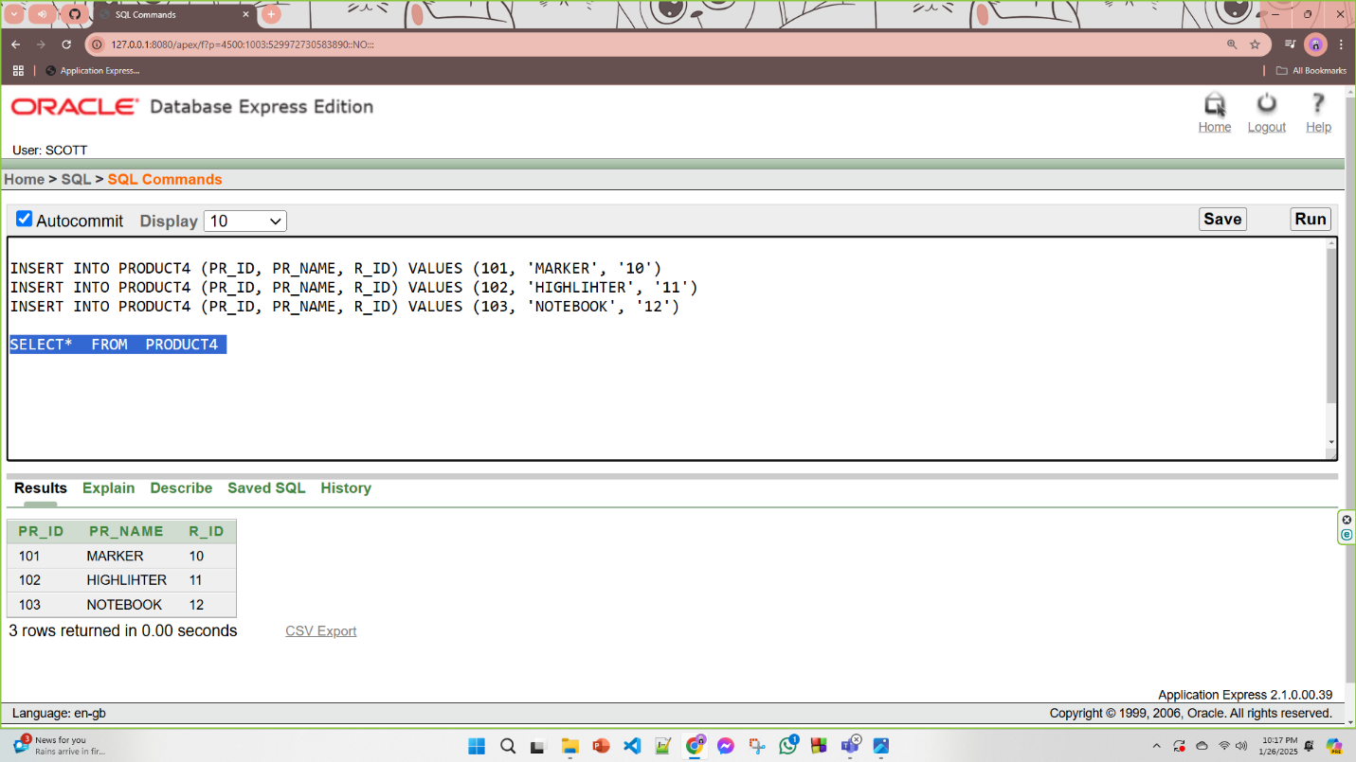

**5)Payment**

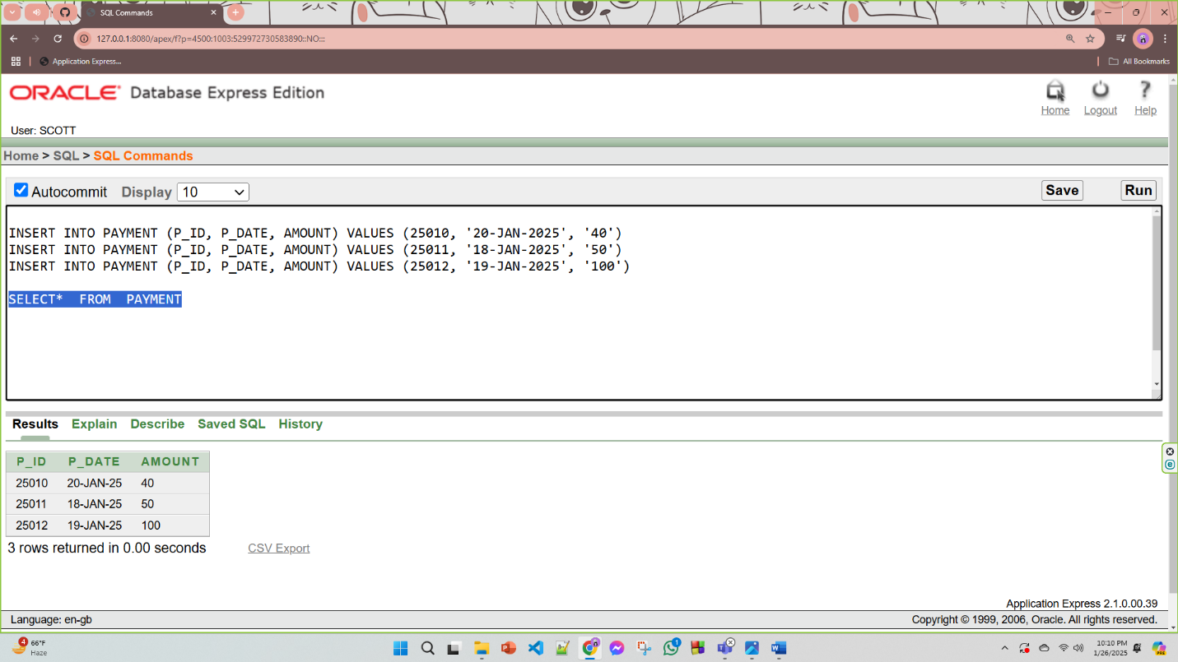

**6)Category**

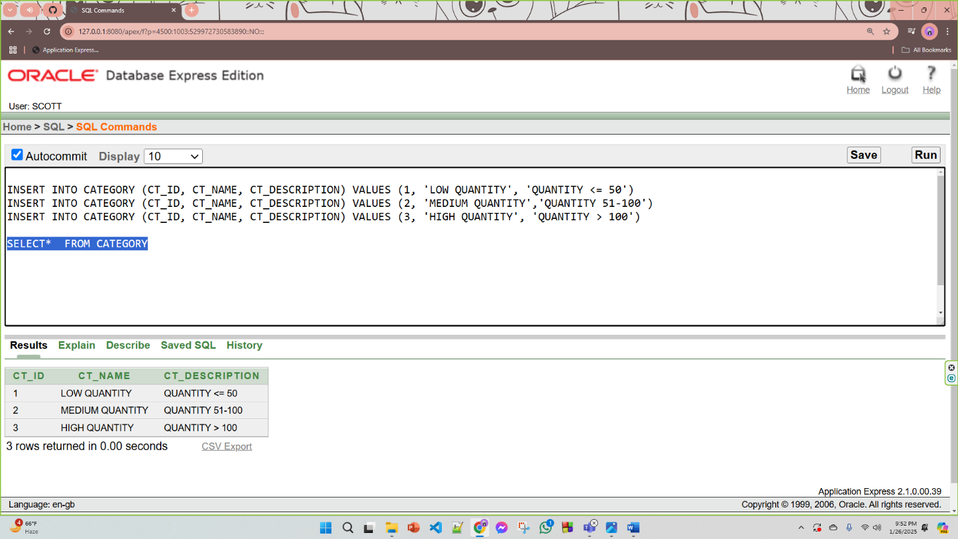

**7)Data**

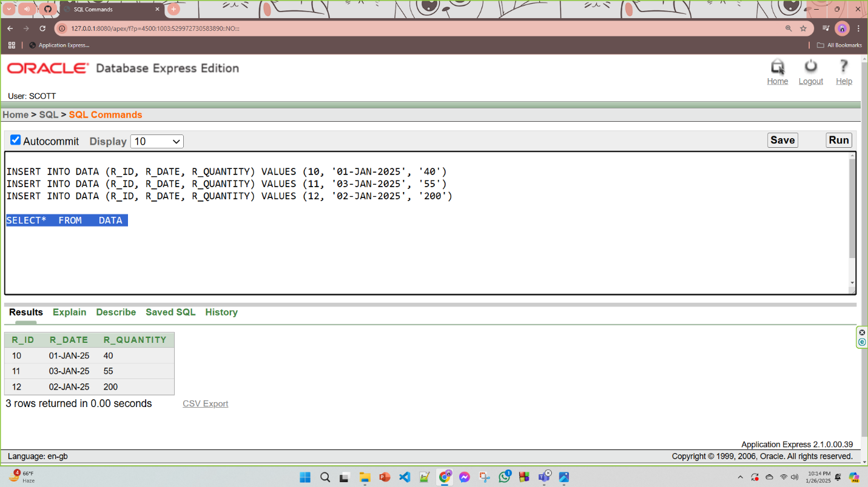

# **Query Test in DB**

1. **simple query:** Write a query to display the name, Id number for all customers.

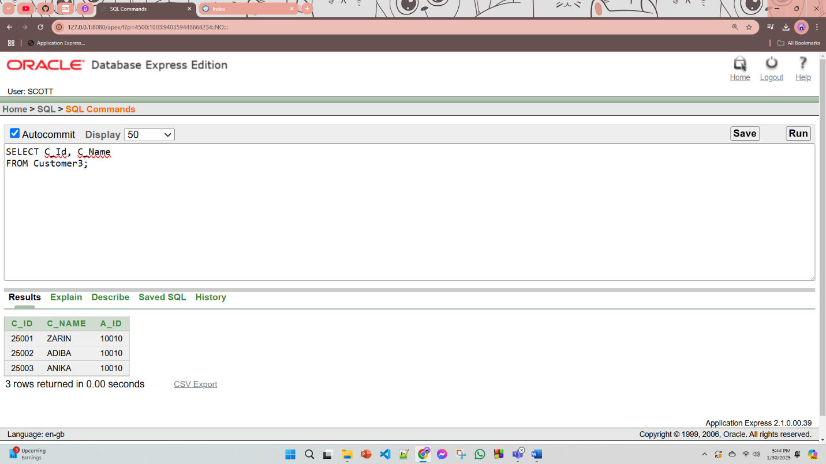

1. **Query with a single row function:** Write a single-row function for the delivery_details2 table, let's use the UPPER() function to convert the id, city, and country to uppercase for each row.

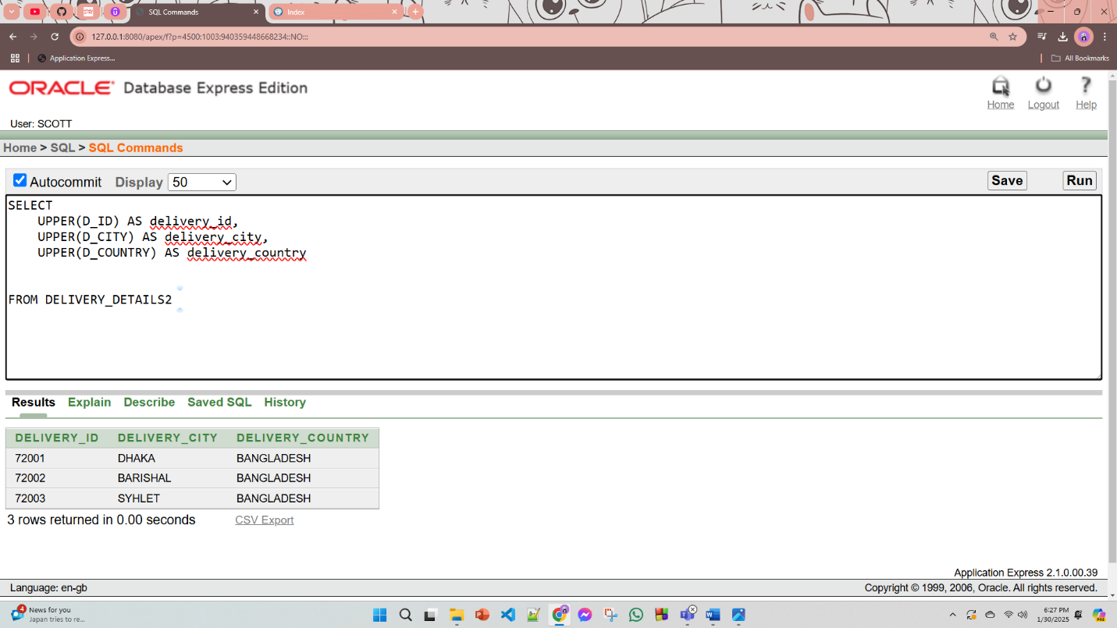

1. **Query with a Multiple row function/ aggregate function**

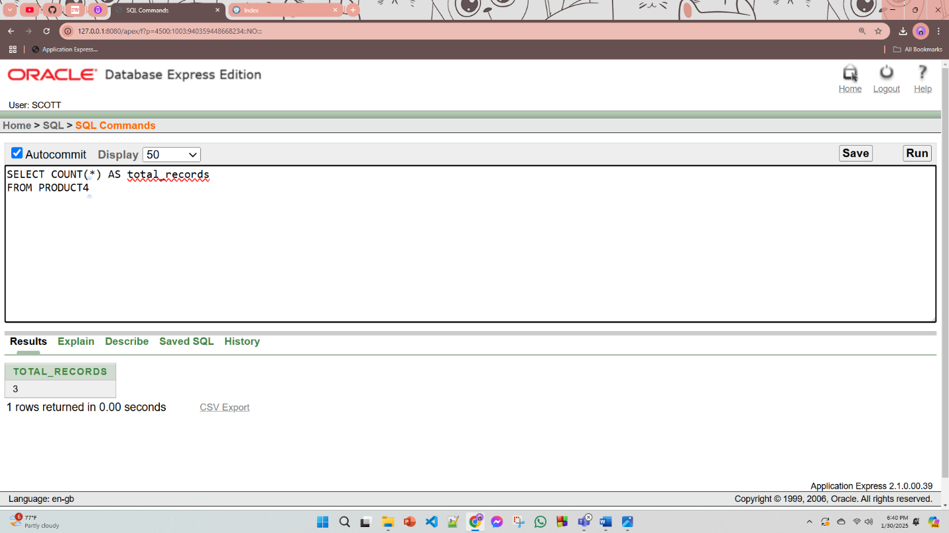

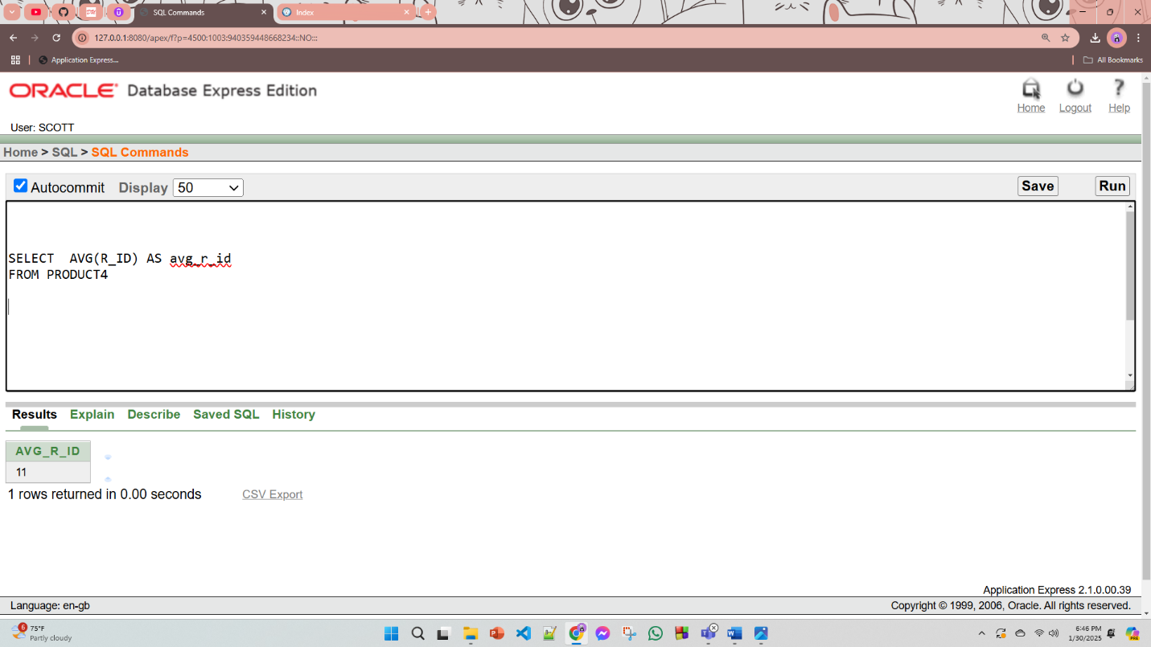

1. **2 Single row subquery and 2 multiple row subquery :**  i)Write a query find the name of product with the highest R_ID in the PRODUCT4 table.

ii)Write a query find the id of the product with the lowest R_ID in the PRODUCT4 table.

**i)Single row**

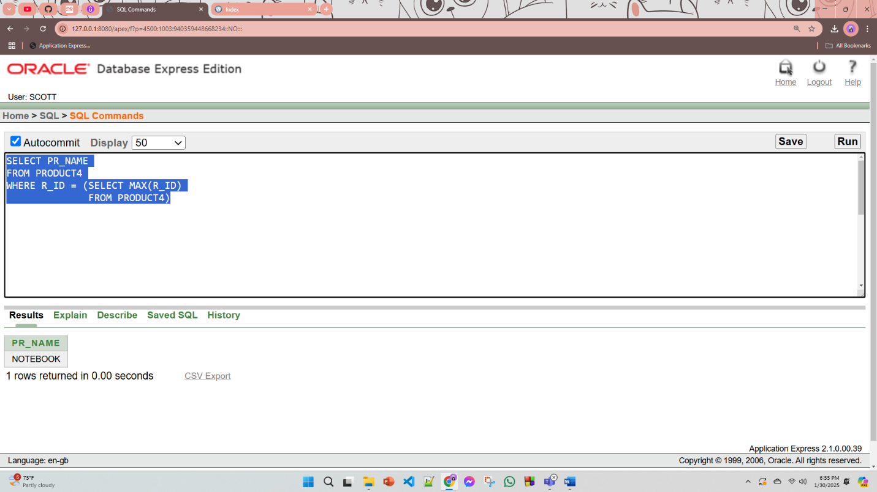

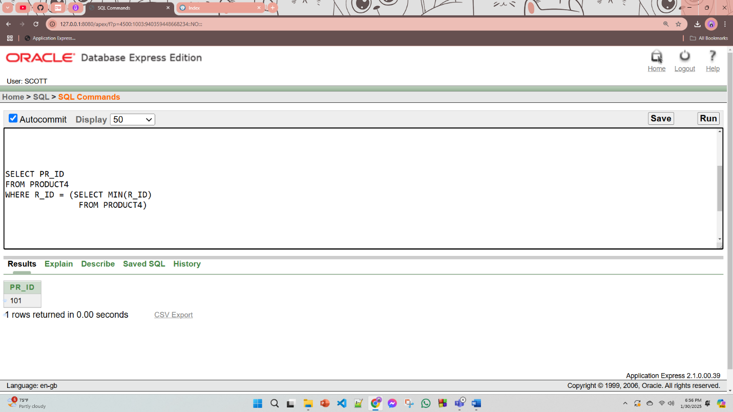

**ii)Multiple row subquery**

Write a query the IDs, names, and descriptions of categories from the CATEGORY table where the category name contains "LO" or "IG".

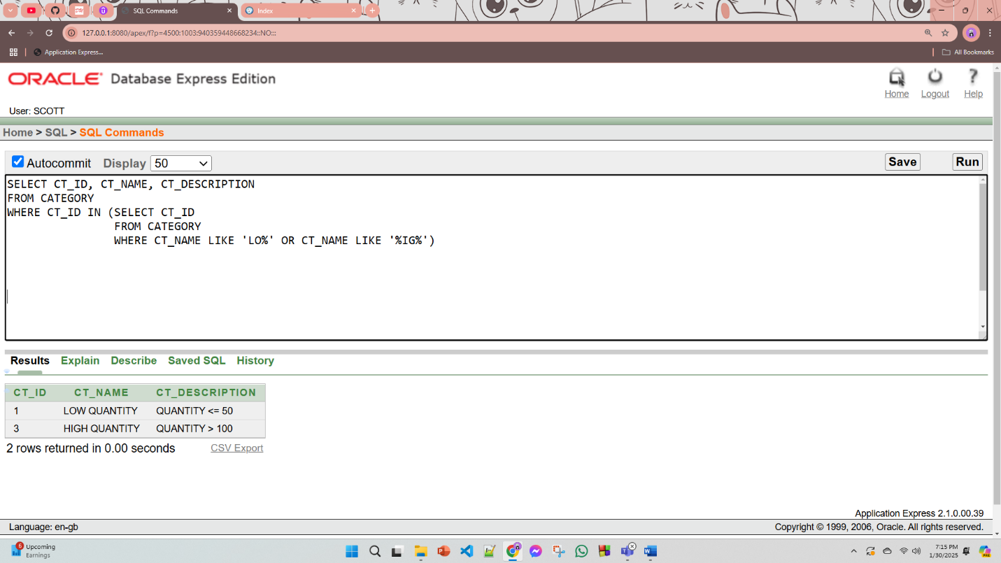

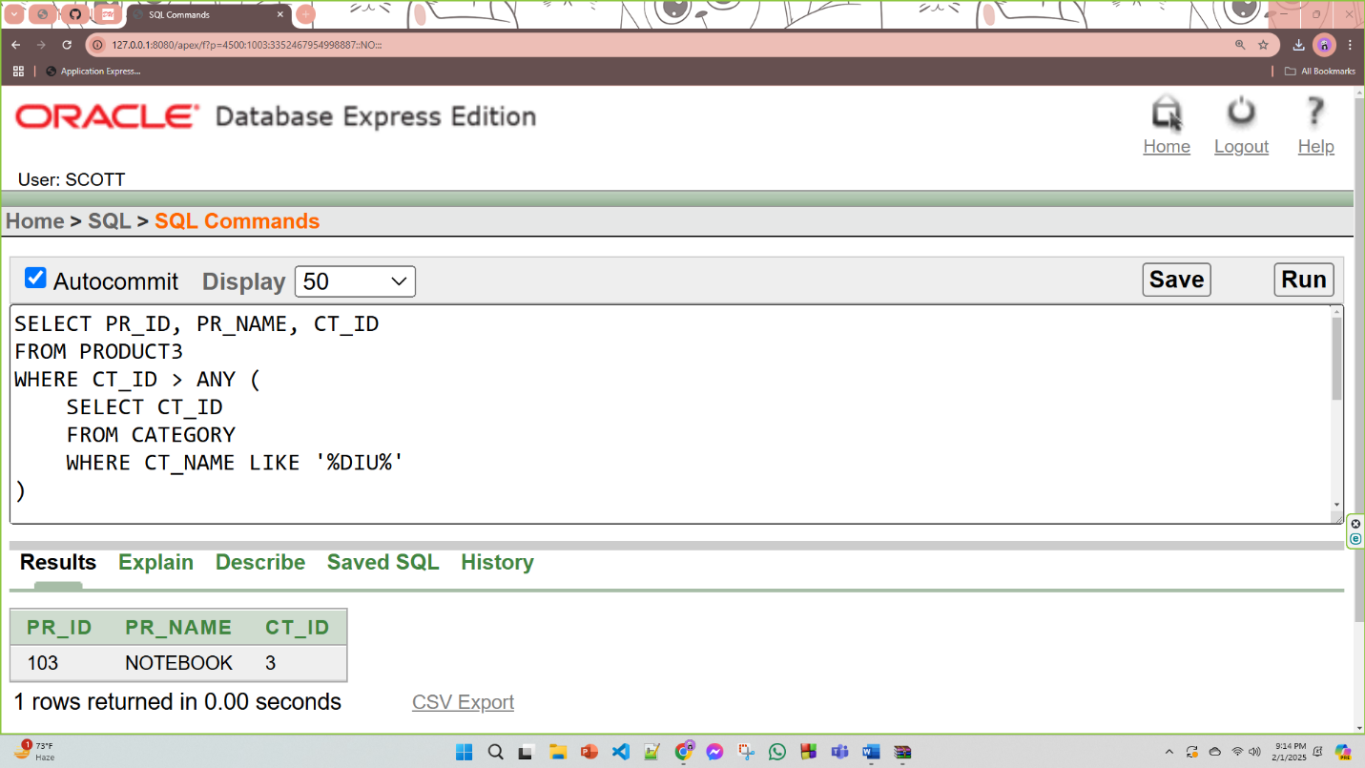

1. **4 kinds of joining**

**i)Equijoin**

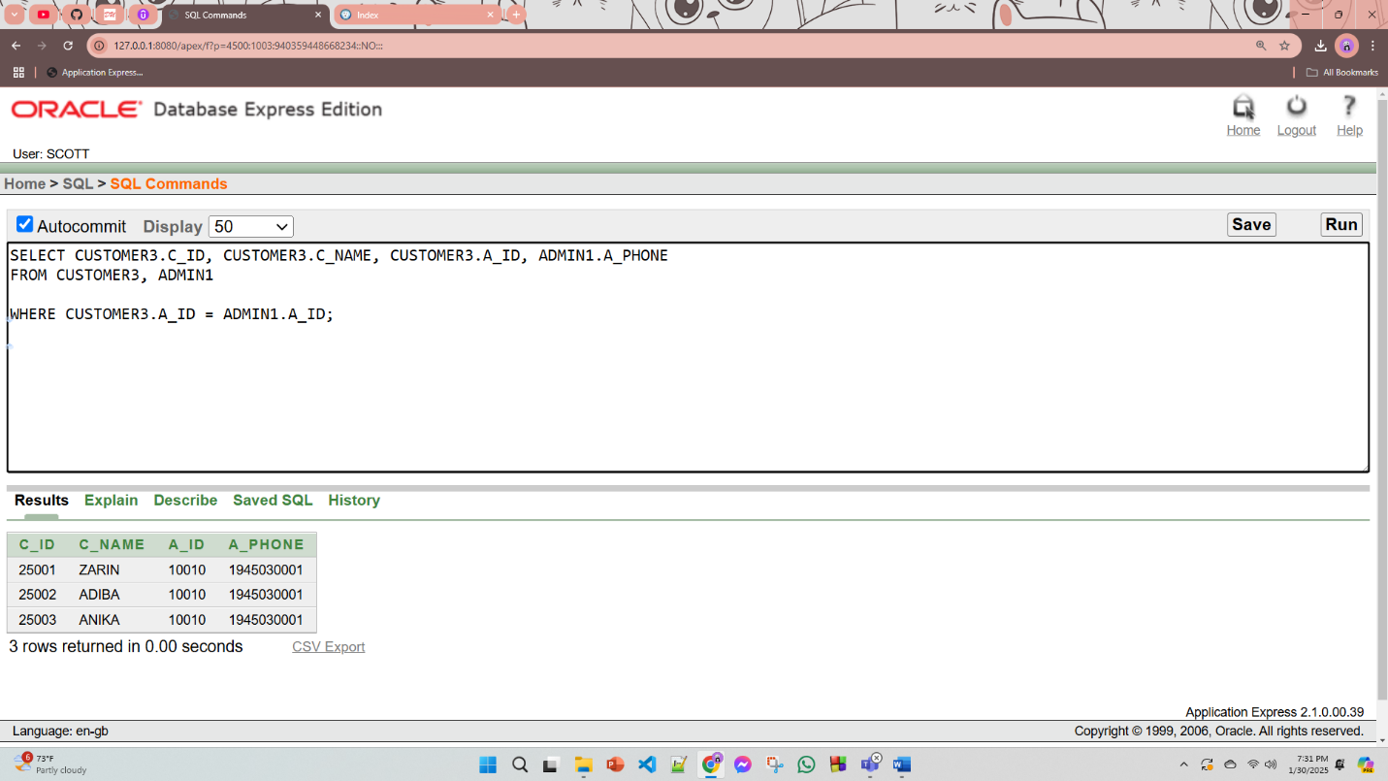

**ii)Non-Equijoin**

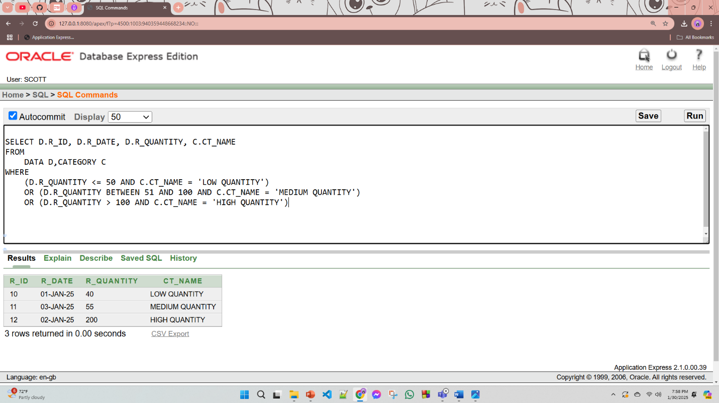

**iii) Self Join**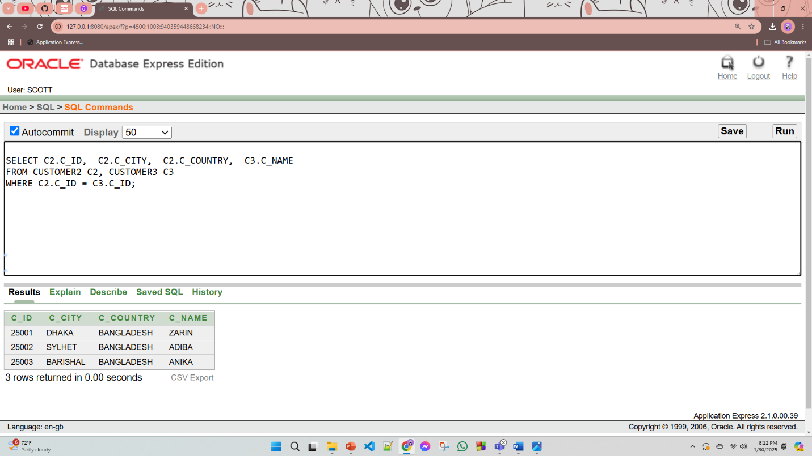

**iv)Outer join**

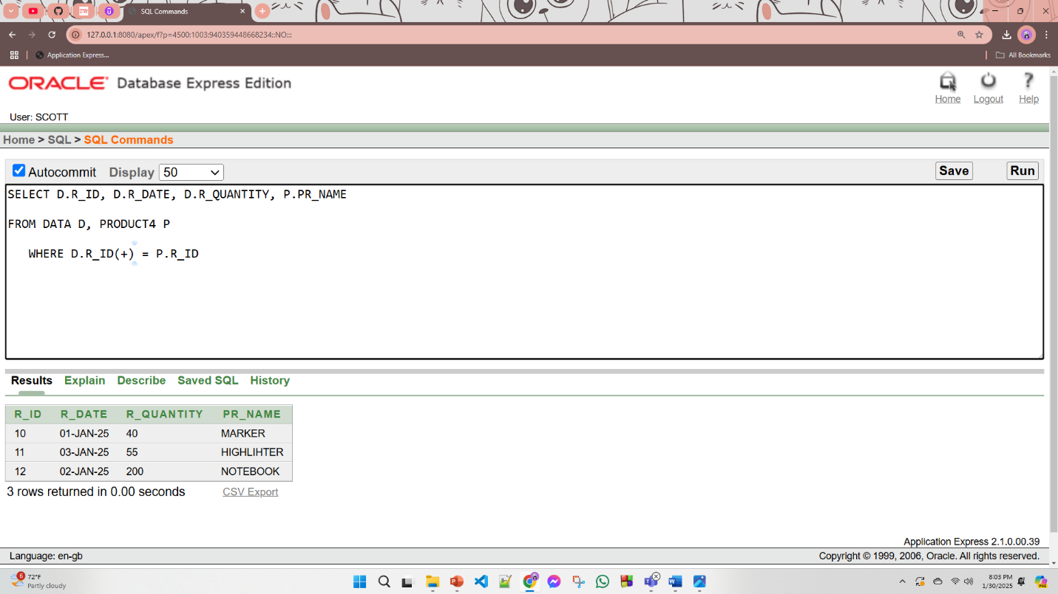

**1 simple view:**

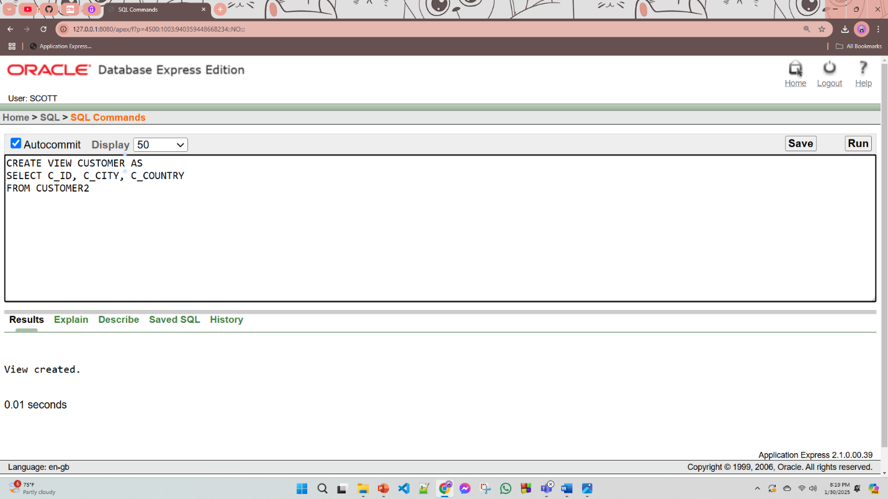

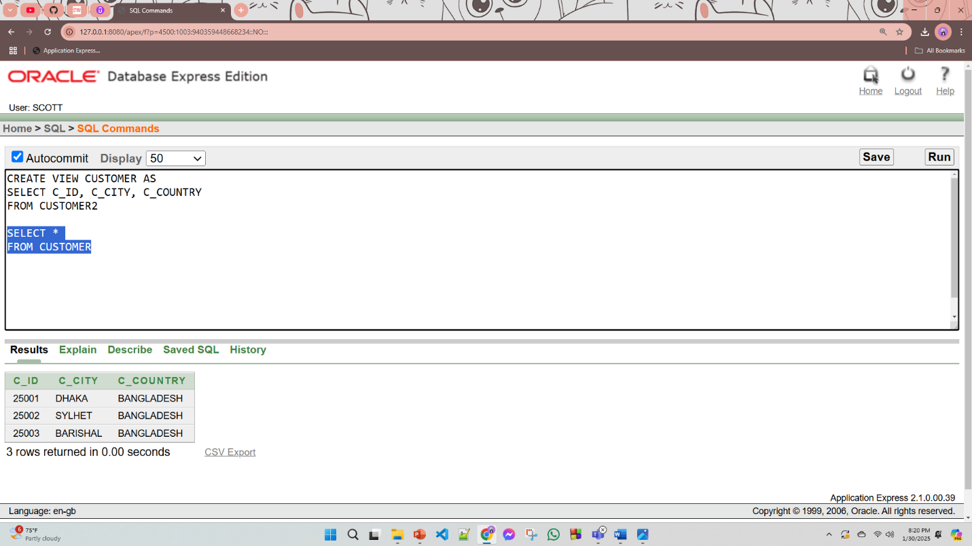

**1 complex view:**

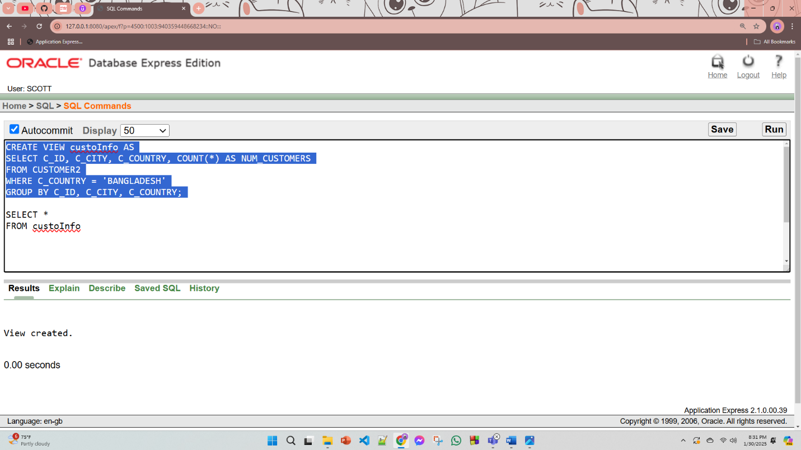

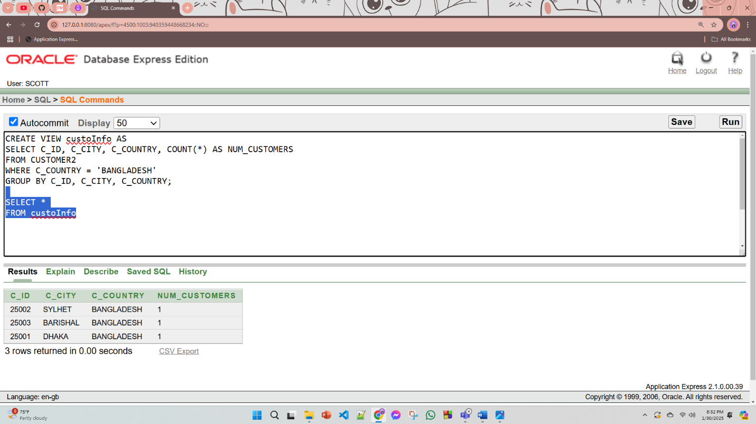

# **Description of a Successful DB connection**

**Student ID: 23-53089-3**

**Name: Anika Tabassum**

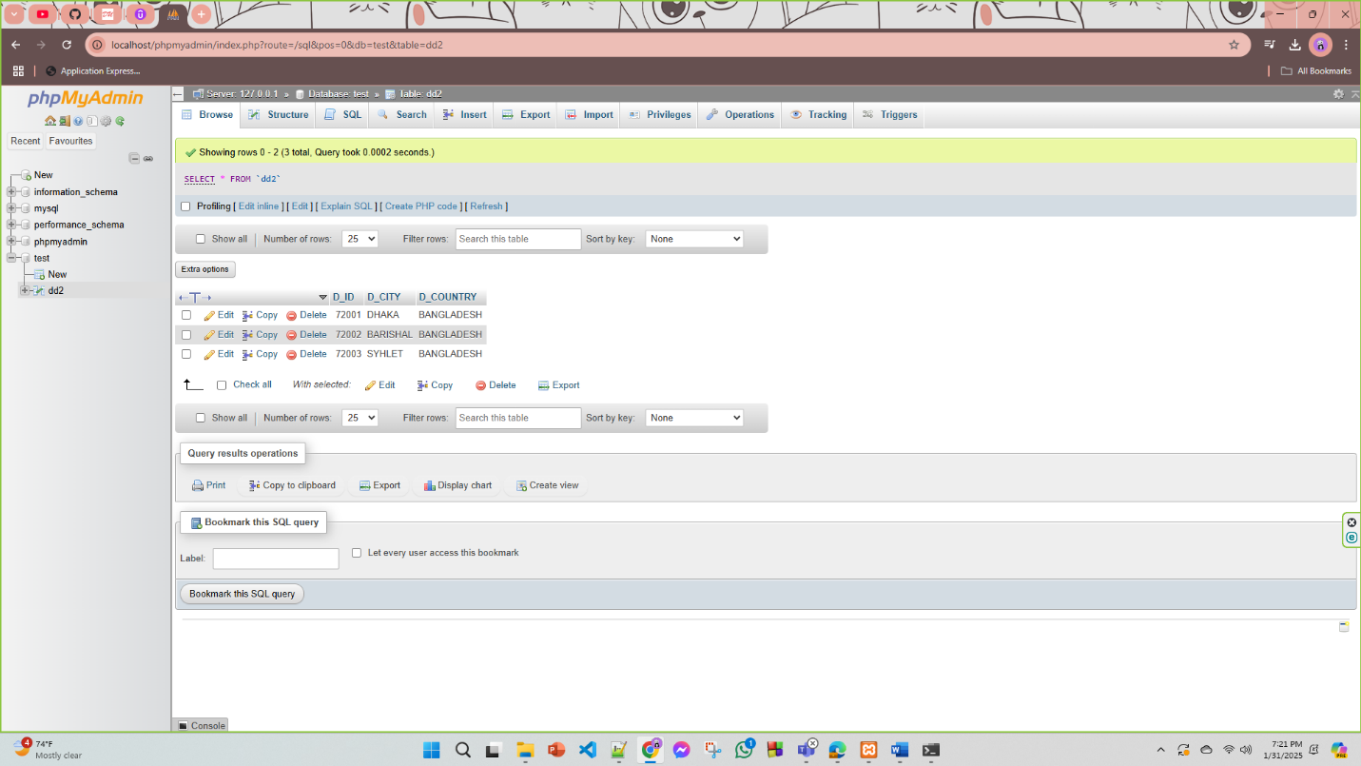

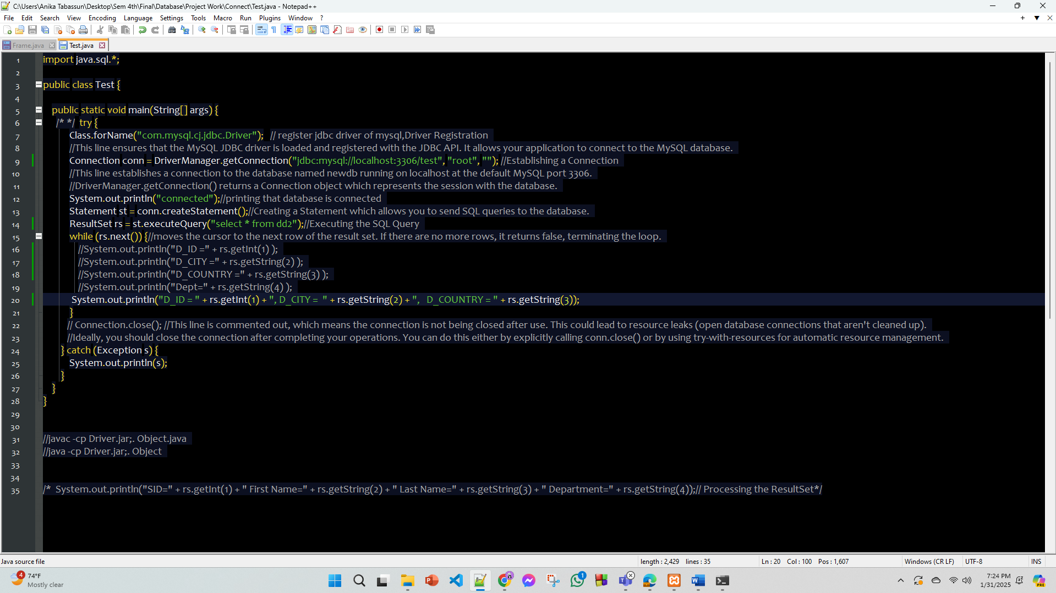

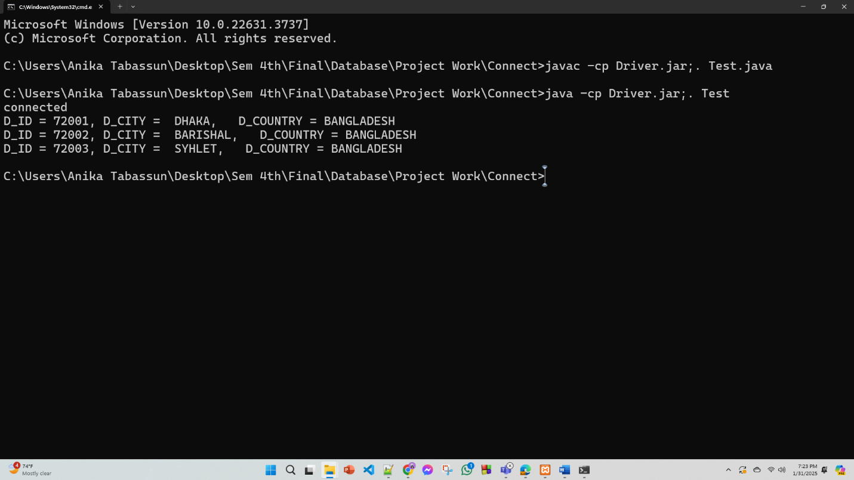

**Student ID: 23-55874-3**

**Name: Zarin Anan**

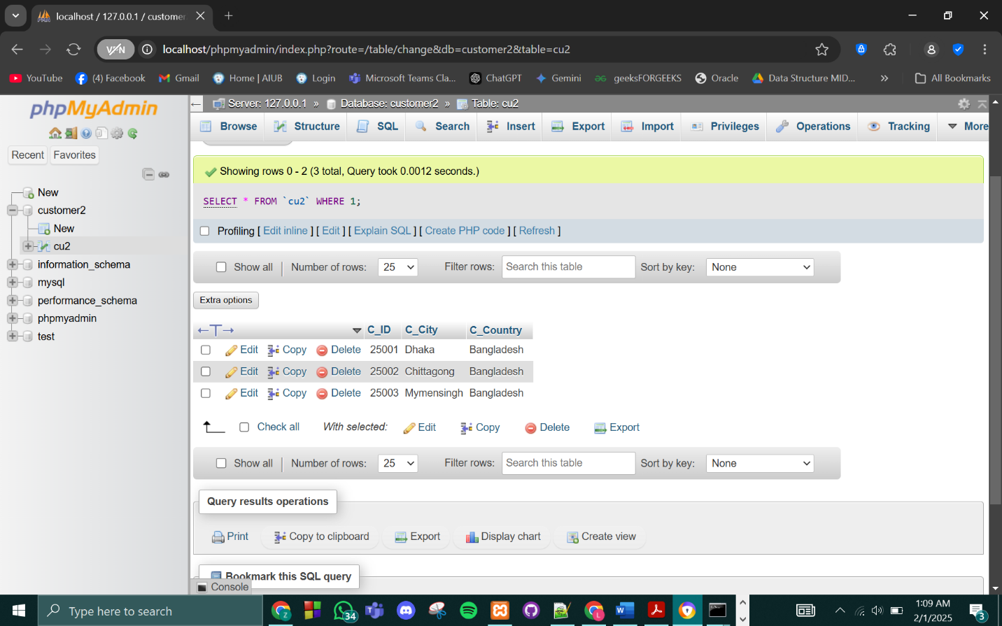

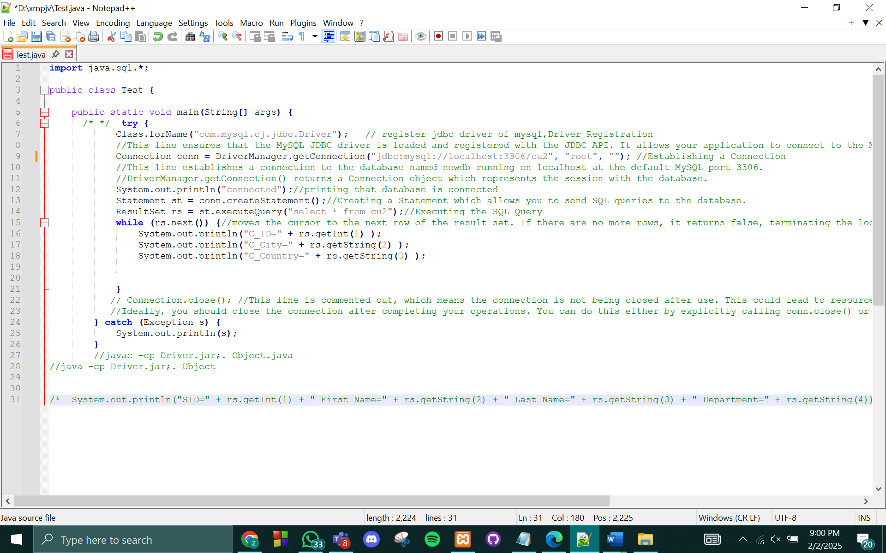

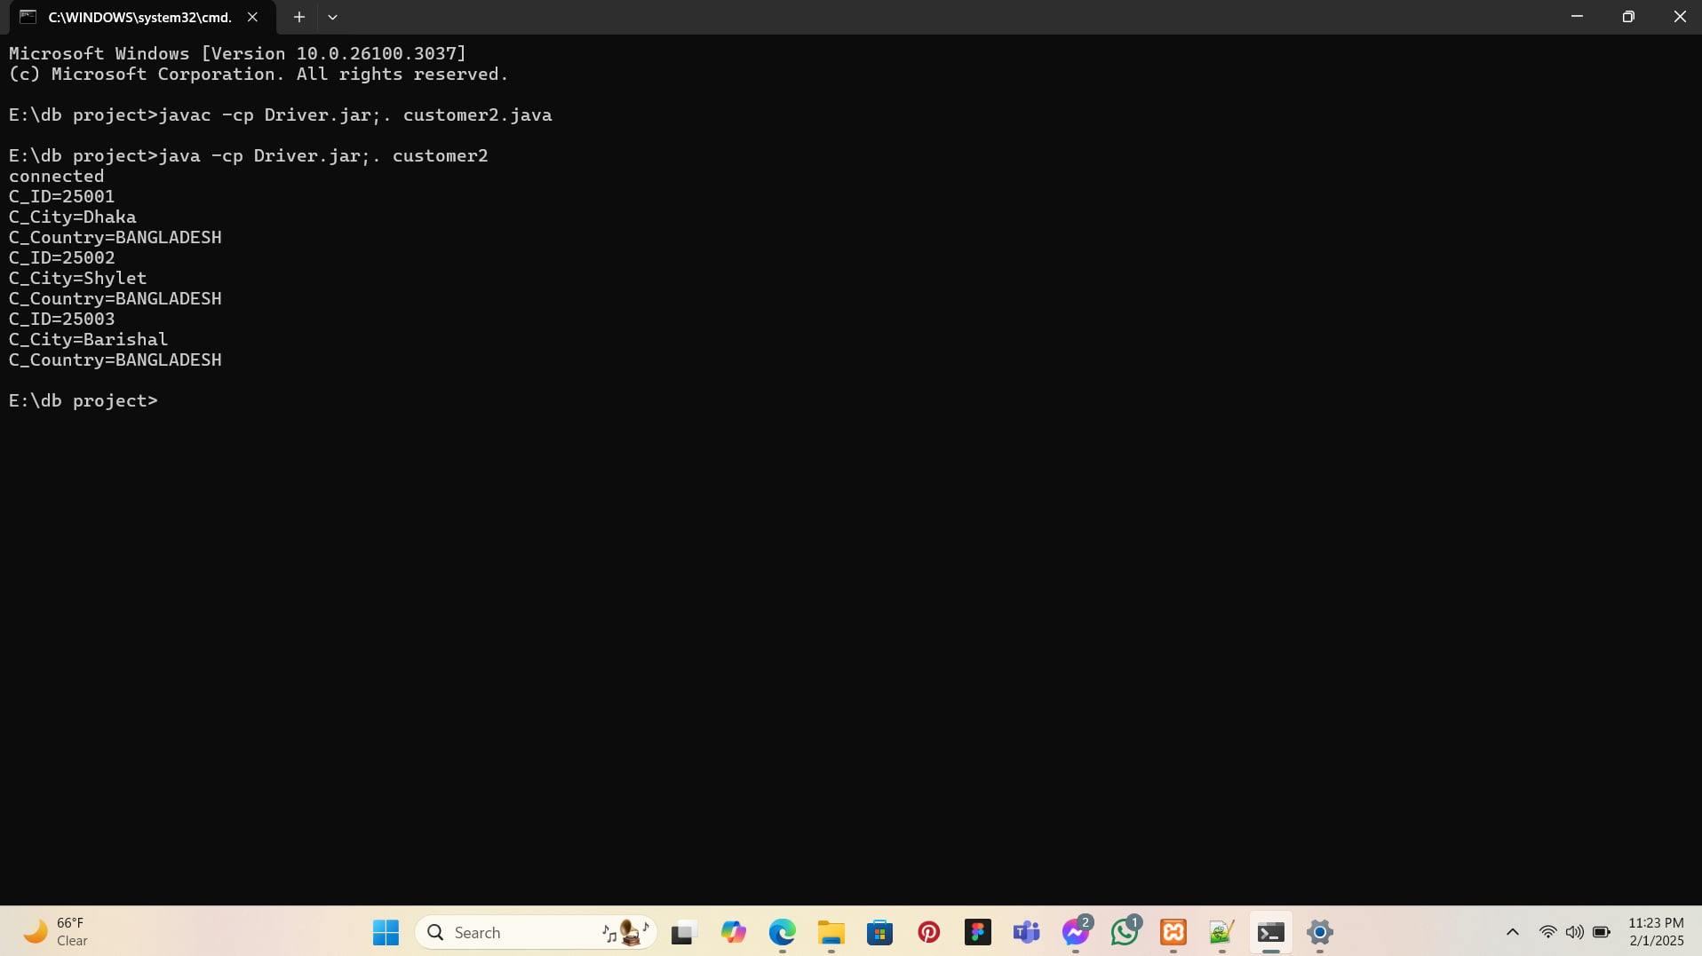

**Student ID: 23-53459-3**

**Name: Adiba Rahman Rudiya**

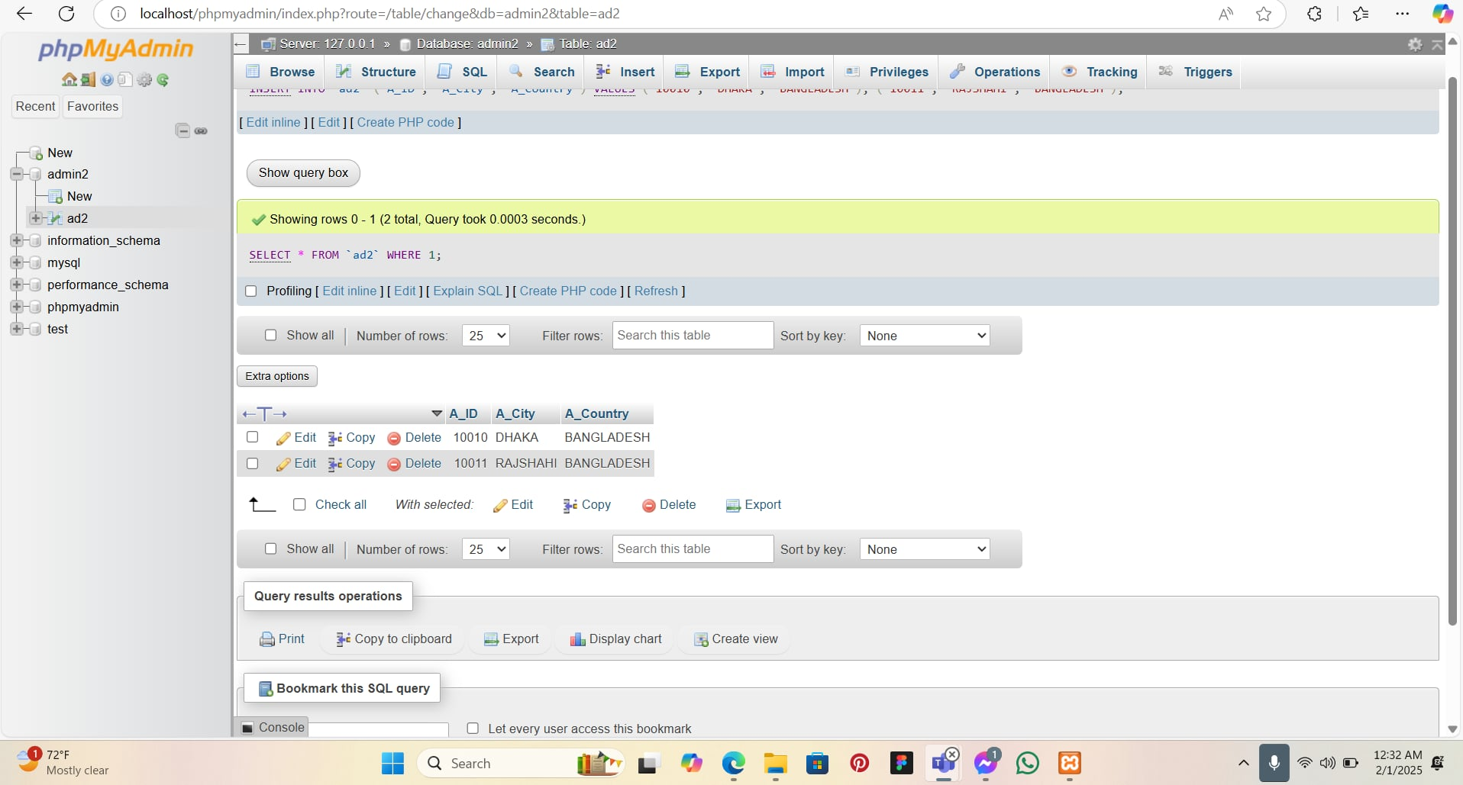

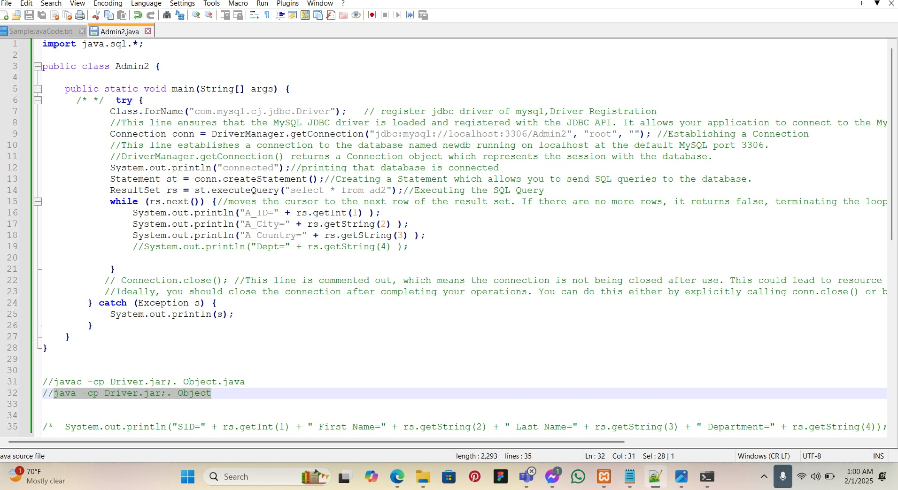

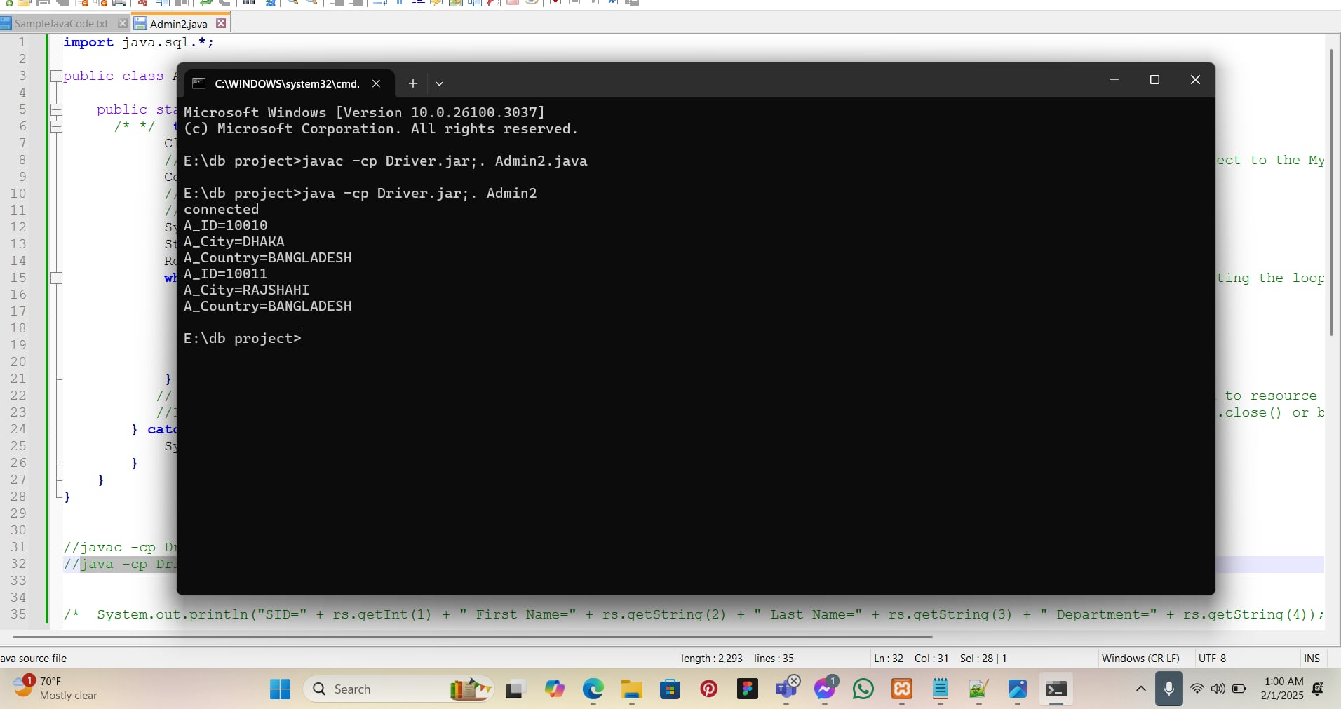

# **Conclusion**

The Product Ordering and Management System is designed to streamline purchasing, payment processing, and delivery tracking by efficiently organizing data and ensuring smooth transactions. By defining key entities, attributes, primary keys, and relationships, the system enhances business operations, improves customer experience, and ensures better record-keeping. Its structured approach helps businesses manage orders, categorize products, and maintain secure payment and delivery processes.

Looking ahead, the system has the potential for significant advancements. Integrating AI and automation can enhance personalized product recommendations and streamline order processing. Advanced security features such as multi-layer authentication and fraud detection can further safeguard transactions. Additionally, incorporating real-time tracking for deliveries, scalability for multi-vendor support, and a mobile application can make the platform more accessible and efficient. With continuous innovation, this system can evolve into a fully automated, AI-driven, and secure e-commerce solution, providing businesses with a competitive edge while improving customer satisfaction.